Appendix 1 Prescription Endorsement

. 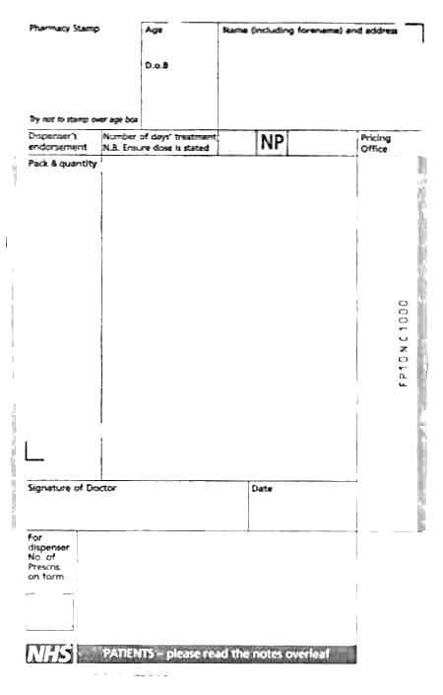
ND
1) Tab Paracetamol

Sig. 1-2 q.d.s. p.r.n.

Mitte 100 tablets

2) Salbutamol Inhaler x 1op

Sig. Use 1 puff t.d.s. p.r.n.

3) Beclomethasone 100 mcg Inhaler x 1 op

Sig One puff b.d.

Note that the ND endorsement is level with the ‘Not Dispensed’ item (paracetamol)

Prescription Endorsement

The item(s) not being supplied should be crossed through and be clearly endorsed as ‘Not Dispensed’ or ‘ND’.

Such endorsements must be on the same level as the item(s) and be in the main body of the prescription, NOT in the endorsement column.

