

QIPP Areas
Resource Pack

2025-26

QIPP – Quality, Innovation, Productivity and Performance

Version 6.0
November 2025
Please note that this document has not been updated for the 2026-27 incentive scheme. Standard Operating Procedures (SOPs) for medicines optimisation switches/reviews, along with other supporting materials, were originally developed for use by Medicines Optimisation Team staff within NHS South Yorkshire Integrated Care Board (ICB). Other organisations or groups choosing to use this resource does so at their own risk and NHS SY ICB accepts no liability for its use or application.

Cost information in this pack has been taken from the Drug Tariff and eMIMS.

V1.0 QIPP Areas (medicines) – Please note price information is from June 2025
- Buprenorphine 7day patch (5 micrograms/hr, 10micrograms/hr, 15micrograms/hr & 20 micrograms/hr) to Sevodyne® patch
V2.0 QIPP Areas (medicines) – Please note price information is from June 2025
- Fentanyl patches to Opiodur® patches
V3.0 QIPP Areas (medicines) – Please note price information is from August 2025
- Venlafaxine MR capsules/tablets to Vencarm® capsules
- Sodium Picosulfate liquid to Dulcolax® liquid
V4.0 QIPP Areas (medicines) – Please note price information is from September 2025
- Estriol 0.01% cream to Estriol 0.1% cream
- Riluzole 50 mg generic tablet to riluzole 50mg orodispersible film (Emylif®)
V5.0 QIPP Areas (medicines) – Please note price information is from October 2025
- Simple eye ointment to Xailin® night
- Tiotropium hard capsules for inhalation to Tiogiva®
V6.0 QIPP Areas (medicines) – Please note price information is from November 2025
- Clenil® MDI to Soprobec® MDI (patients who were not reviewed as part of the 24 25 scheme)

Equality and Diversity
Please consider equality and diversity when undertaking these medicine reviews. In particular, consider how best to communicate any changes to patients whose first language is not English or those with impaired sight.

References:
Drug Tariff June 2025
Tariff.book
Drug Tariff August 2025
Tariff.book
Drug Tariff September 2025
Tariff.book
Drug Tariff October 2025
Tariff.book
Drug Tariff November 2025
Tariff.book

eMIMS
Database of prescription and generic drugs, clinical guidelines | MIMS online
Back to contents
Buprenorphine 7day patch (5 micrograms/hr, 10 micrograms/hr, 15 micrograms/hr and 20 micrograms/hr) to
Sevodyne® patch
Potential target medicines | - Generic Buprenorphine 5 micrograms/hr, 10 micrograms/hr, 15 micrograms/hr and 20 micrograms/hr patch  - Branded/branded generic Buprenorphine 5 micrograms/hr, 10 micrograms/hr, 15 micrograms/hr and 20 micrograms/hr patch (excluding Sevodyne®
From: | To: | Potential annual cost saving/patient (based on 4 patches per month):
Buprenorphine 5 micrograms/hr patch x 4 (£17.60) | Sevodyne® 5 micrograms/hr patch x 4 (£5.53) | £145
Butrans® 5 micrograms/hr patch x 4 (£17.60) | Sevodyne® 5 micrograms/hr patch x 4 (£5.53) | £145
Butec® 5 micrograms/hr patch x 4 (£7.92) | Sevodyne® 5 micrograms/hr patch x 4 (£5.53) | £29
Reletrans® 5 micrograms/hr patch x 4 (£6.34) | Sevodyne® 5 micrograms/hr patch x 4 (£5.53) | £10
Buprenorphine 10 micrograms/hr patch x 4 (£31.55) | Sevodyne® 10 micrograms/hr patch x 4 (£9.93) | £259
Butrans® 10 micrograms/hr patch x 4 (£31.55) | Sevodyne® 10 micrograms/hr patch x 4 (£9.93) | £259
Butec® 10 micrograms/hr patch x 4 (£14.20) | Sevodyne® 10 micrograms/hr patch x 4 (£9.93) | £51
Panitaz® 10 micrograms/hr patch x 4 (£12.62) | Sevodyne® 10 micrograms/hr patch x 4 (£9.93) | £32
Reletrans® 10 micrograms/hr patch x 4 (£11.36) | Sevodyne® 10 micrograms/hr patch x 4 (£9.93) | £51
Buprenorphine 15 micrograms/hr patch x 4 (£49.15) | Sevodyne® 15 micrograms/hr patch x 4 (£15.48) | £404
Butrans® 15 micrograms/hr patch x 4 (£49.15) | Sevodyne® 15 micrograms/hr patch x 4 (£15.48) | £404
Butec® 15 micrograms/hr patch x 4 (£22.12) | Sevodyne® 15 micrograms/hr patch x 4 (£15.48) | £80
Reletrans® 15 micrograms/hr patch x 4 (£17.70) | Sevodyne® 15 micrograms/hr patch x 4 (£15.48) | £27
Buprenorphine 20 micrograms/hr patch x 4 (£57.46) | Sevodyne® 20 micrograms/hr patch x 4 (£18.09) | £472
Butrans® 20 micrograms/hr patch x 4 (£57.46) | Sevodyne® 20 micrograms/hr patch x 4 (£18.09) | £472
Butec® 20 micrograms/hr patch x 4 (£25.86) | Sevodyne® 20 micrograms/hr patch x 4 (£18.09) | £93
Panitaz® 20 micrograms/hr patch x 4 (£22.98) | Sevodyne® 20 micrograms/hr patch x 4 (£18.09) | £59
Reletrans® 20 micrograms/hr patch x 4 (£20.06) | Sevodyne® 20 micrograms/hr patch x 4 (£18.09) | £24

Process for implementing this change | - Search for patients aged 18 years and over prescribed (on repeat) generic buprenorphine 5 micrograms/hr, 10 micrograms/hr, 15 micrograms/hr and 20 micrograms/hr patch or any of the following brands Butec®, Butrans® Panitaz® or Reletrans®  - Exclude those patients:  - who are prescribed an alternative brand and have specified they can only use this brand.  - who have previously been prescribed the Sevodyne® brand and have experienced problems with it. Prescribe as the brand the patient is using where possible (buprenorphine patches should be prescribed by brand name). Note: patients who have previously switched back to the generic or other brand due to historical stock availability issues with Sevodyne® should not be excluded.  - who have previously declined the switch where this is documented in the patient’s record (please note that this is not an absolute exclusion and professional judgement should be exercised, for example if the switch was declined a number of years ago for a particular reason and/or where circumstances have since changed it may potentially be appropriate to offer the switch again).  - using 2 patches of different strengths and where only one strength patch can be switched to the Sevodyne® brand (for example, Reletrans® is also available as 25 micrograms/hr, 30 microgram/hr and 40microgram/hr).  - prescribed any combination of buprenorphine patches that exceed 40mcg/hr (this is the maximum dose stated in SPC)  - Points for consideration:  - The excipients vary between the different brands of buprenorphine 7 day patch. Use of Sevodyne® patch is contraindicated in patients who are hypersensitive to any of the excipients in section 6.1 of the SPC. Link to emc  - Guidance is available on the use of strong opioids in Barnsley https://best.barnsleyccg.nhs.uk/media/w2vbyux0/guidance-on-the-use-of-strong-opioids.pdf?UNLID=80522212025610164126  - Recommend a change to Sevodyne® brand where appropriate.  - It is recommended that if you are changing any care home patients, that the care home is telephoned to inform them of the change in advance of sending the letter. All CQC registered care homes have an nhs.net email address (or secure equivalent) so emailing them the patient letter can be offered as an option instead of posting. It is also recommended that the community pharmacy is informed of the change so that they are aware.  - Practices are encouraged to change patients via letter. Letters can be sent via AccuRx or post, please check individual patient records for any preferred method of communication (patients with older phones may not be able to access the letters via links etc). A template patient letter can be found in Appendix B1. A copy of the following patient information leaflet can also be enclosed with or embedded within the letter; Fentanyl and buprenorphine skin patches: How to use and dispose of them safely.https://best.barnsleyccg.nhs.uk/media/1i2g05rg/fentanyl-and-buprenorphine-transdermal-patch-safety-leaflet.pdfhttps://best.barnsleyccg.nhs.uk/media/1i2g05rg/fentanyl-and-buprenorphine-transdermal-patch-safety-leaflet.pdf [please do not include a direct link to the guideline on the BEST website within the patient letter]  - In order to avoid potential confusion, the generic drug name should be included as an additional prescription note on the drug entry on the system. Instructions on how to do this can be found in Appendix C & Appendix D.  - Check previous drug has been stopped when new drug has been added. Include the reason for change as ‘prescribed as the cost effective brand Sevodyne®.’  - Make a corresponding entry* in the patient’s record detailing the change and the method of communication with the patient (e.g. telephone call with patient, letter and medication changes leaflet sent to patient etc.) on the same day the medication is changed.  *it is recommended that an entry is made in the patient’s new journal (SystmOne) or within consultations (Emis)/consultation history (Vision) in order to provide a robust audit trail.

Data Collection

 | Number of patients | Number of patients changed to Sevodyne® | Cost savings
Buprenorphine 5 micrograms/hr patch x 4 (£17.60)
Butrans® 5 micrograms/hr patch x 4 (£17.60)
Butec® 5 micrograms/hr patch x 4 (£7.92)
Reletrans® 5 micrograms/hr patch x 4 (£6.34)
Buprenorphine 10 micrograms/hr patch x 4 (£31.55)
Butrans® 10 micrograms/hr patch x 4 (£31.55)
Butec® 10 micrograms/hr patch x 4 (£14.20)
Panitaz® 10 micrograms/hr patch x 4 (£12.62)
Reletrans® 10 micrograms/hr patch x 4 (£11.36)
Buprenorphine 15 micrograms/hr patch x 4 (£49.15)
Butrans® 15 micrograms/hr patch x 4 (£49.15)
Butec® 15 micrograms/hr patch x 4 (£22.12)
Reletrans® 15 micrograms/hr patch x 4 (£17.70)
Buprenorphine 20 micrograms/hr patch x 4 (£57.46)
Butrans® 20 micrograms/hr patch x 4 (£57.46)
Butec® 20 micrograms/hr patch x 4 (£25.86)
Panitaz® 20 micrograms/hr patch x 4 (£22.98)
Reletrans® 20 micrograms/hr patch x 4 (£20.06)

Back to contents
Fentanyl/ non-formulary branded fentanyl patches to Opiodur® patches
Potential target medicines | - Generic fentanyl patches 12/25/50/75/100microgram/hour  - Durogesic® DTrans patches 12/25/50/75/100microgram/hour  - Matrifen® patches 12/25/50/75/100microgram/hour  - Mezolar® Matrix 12/25/50/75/100microgram/hour  - Victanyl® patches 12microgram/25/50/75/100microgram/hour

From: | To: | Potential annual cost saving/patient for 12mths (based on 10 patches per month):
Generic fentanyl OR Durogesic® DTrans OR Yemex® patches 12 microgram x 5 (£12.59) | Opiodur® patches 12 microgram/hr x 5 (£5.64) | £166.80
Matrifen® patches 12 microgram patches x 5 (£7.52) | Opiodur® patches 12 microgram/hr x 5 (£5.64) | £45.12
Mezolar® Matrix 12 microgram patches x 5 (£7.53) | Opiodur® patches 12 microgram/hr x 5 (£5.64) | £45.36
Victanyl® patches 12 microgram patches x 5 (£12.58) | Opiodur® patches 12 microgram/hr x 5 (£5.64) | £166.56
Generic fentanyl patches OR Durogesic® DTrans OR Yemex® 25 microgram x 5 (£17.99) | Opiodur® patches 25 microgram/hr x 5 (£8.07) | £47.28
Matrifen® patches 25 microgram patches x 5 (£10.76) | Opiodur® patches 25 microgram/hr x 5 (£8.07) | £64.56
Mezolar® Matrix 25 microgram patches x 5 (£10.77) | Opiodur® patches 25 microgram/hr x 5 (£8.07) | £64.80
Victanyl® patches 25 microgram patches x 5 (£25.89) | Opiodur® patches 25 microgram/hr x 5 (£8.07) | £427.68
Generic fentanyl OR Durogesic® DTrans OR Yemex® patches 50 microgram x 5 (£33.66) | Opiodur® patches 50 microgram/hr x 5 (£15.09) | £445.68
Matrifen® patches 50 microgram patches x 5 (£20.12) | Opiodur® patches 50 microgram/hr x 5 (£15.09) | £120.72
Mezolar® Matrix 50 microgram patches x 5 (£20.13) | Opiodur® patches 50 microgram/hr x 5 (£15.09) | £120.96
Victanyl® patches 50 microgram patches x 5 (£48.36) | Opiodur® patches 50 microgram/hr x 5 (£15.09) | £798.48
Generic fentanyl OR Durogesic® DTrans OR Yemex® patches 75 microgram x 5 (£46.99) | Opiodur® patches 75 microgram/hr x 5 (£21.05) | £622.56
Matrifen® patches 75 microgram patches x 5 (£28.06) | Opiodur® patches 75 microgram/hr x 5 (£21.05) | £168.24
Mezolar® Matrix 75 microgram patches x 5 (£28.07) | Opiodur® patches 75 microgram/hr x 5 (£21.05) | £168.48
Victanyl® patches 75 microgram patches x 5 (£67.41) | Opiodur® patches 75 microgram/hr x 5 (£21.05) | £1,112.64
Generic fentanyl OR Durogesic® DTrans OR Yemex® patches 100 microgram x 5 (£57.86) | Opiodur® patches 100 microgram/hr x 5 (£25.94) | £766.08
Matrifen® patches 100 microgram patches x 5 (£34.57) | Opiodur® patches 100 microgram/hr x 5 (£25.94) | £207.12
Mezolar® Matrix 100 microgram patches x 5 (£34.60) | Opiodur® patches 100 microgram/hr x 5 (£25.94) | £207.84
Victanyl® patches 100 microgram patches x 5 (£86.09) | Opiodur® patches 100 microgram/hr x 5 (£25.94) | £1443.60

Process for implementing this change | - Search for patients prescribed (on repeat) generic fentanyl, Durogesic® DTrans, Matrifen®, Mezolar® or Victanyl® 12/25/50/75 and 100 microgram patches.  - Exclude those patients:  - Who have previously been prescribed Opiodur® patches and have experienced problems with them. Prescribe as the brand the patient is using where possible (fentanyl patches should be prescribed by brand name).  - Who are prescribed an alternative brand and have specified they can only use this brand.  - Who have previously declined the switch where this is documented in the patient’s record (please note that this is not an absolute exclusion and professional judgement should be exercised, for example if the switch was declined a number of years ago for a particular reason and/or where circumstances have since changed it may potentially be appropriate to offer the switch again).  - Receiving end of life care (patients receiving palliative care can be considered for the switch).  - Points to consider:  - Fentanyl patches should be prescribed by brand and not generically: Example medicines to prescribe by brand name in primary care – SPS - Specialist Pharmacy Service – The first stop for professional medicines advice. (Fentanyl transdermal patches are available as matrix and reservoir formulations. Reservoir patches must not be cut because damage to the rate-limiting membrane can lead to a rapid release of fentanyl resulting in overdose. If the prescriber intends the patch to be cut (NB: unlicensed and not recommended) then the prescription must specify a brand of matrix formulation patch).  - Opiodur® is a matrix patch. Durogesic®, Matrifen®, Mezolar® and Victanyl® patches are also matrix patches. (N.B. We are not aware that any brands of fentanyl reservoir patches are currently available following the previous discontinuation of Fentalis®).  - The excipients vary between the different Fentanyl patches. Use of Opiodur® is contraindicated in patients who are hypersensitive to any of the excipients in section 6.1 of the SPC.  - Guidance is available on the use of strong opioids in Barnsley: https://best.barnsleyccg.nhs.uk/media/w2vbyux0/guidance-on-the-use-of-strong-opioids.pdf?UNLID=80522212025610164126  - Recommend a change to Opiodur® patches where appropriate.  - It is recommended that if you are changing any care home patients, that the care home is telephoned to inform them of the change in advance of sending the letter. All CQC registered care homes have an nhs.net email address (or secure equivalent) so emailing them the patient letter can be offered as an option instead of posting. It is also recommended that the community pharmacy is informed of the change so that they are aware.  - Practices are encouraged to change patients via letter. Letters can be sent via AccuRx or post, please check individual patient records for any preferred method of communication (patients with older phones may not be able to access the letters via links etc). A copy of the following patient information leaflet can also be enclosed with or embedded within the letter; Fentanyl and buprenorphine skin patches: How to use and dispose of them safely.https://best.barnsleyccg.nhs.uk/media/1i2g05rg/fentanyl-and-buprenorphine-transdermal-patch-safety-leaflet.pdfhttps://best.barnsleyccg.nhs.uk/media/1i2g05rg/fentanyl-and-buprenorphine-transdermal-patch-safety-leaflet.pdf [please do not include a direct link to the guideline on the BEST website within the patient letter]  - In order to avoid potential confusion, the generic drug name should be included as an additional prescription note on the drug entry on the system. Instructions on how to do this can be found in Appendix C & Appendix D.  - Check previous drug has been stopped when new drug has been added. Include the reason for change as ‘prescribed as the cost-effective brand Opiodur®'.  - Make a corresponding entry* in the patient’s record detailing the change and the method of communication with the patient (e.g., telephone call with patient, letter and medication changes leaflet sent to patient etc) on the same day the medication is changed.  *it is recommended that an entry is made in the patient’s new journal (SystmOne) or within consultations (Emis) in order to provide a robust audit trail.

Data Collection
 | Number of patients | Number of patients changed to Opiodur® | Cost savings
Fentanyl/brand 12 microgram patches
Fentanyl/brand 25 microgram patches
Fentanyl/brand 50 microgram patches
Fentanyl/brand 75 microgram patches
Fentanyl/brand 100 microgram patches

Venlafaxine XL 37.5mg tablets & capsules to Vencarm® XL 37.5mg capsules
Vensir® XL/ Efexor® XL 75mg capsules to Vencarm®XL 75mg capsules
Venlafaxine XL/branded (Vensir® XL/ Efexor® XL) 150mg capsules to Vencarm® XL 150mg capsules
Venlafaxine XL 225mg tablets & capsules /Vensir® XL 225mg capsules to Vencarm® XL 225mg capsules
Potential target medicines | - Generic Venlafaxine XL 37.5mgcapsules & tablets  - Branded (Vensir® XL/Efexor ® XL) 75mg capsules  - Branded (Vensir® XL/Efexor ® XL) /Generic Venlafaxine XL 150mg capsules  - Branded (Vensir® XL/Efexor® XL) /Generic Venlafaxine XL 225mg capsules & tablets
Only selected strengths/formulations/brands with the largest savings are included in this pack

From: | To: | Potential annual cost saving/patient (based on 1 cap/tab per day
Venlafaxine / Vensir® XL 150mg modified release capsules / x 28 (£9.95) | Vencarm® XL 150mg capsules x 28 (£3.89) | £78.78
Efexor XL 150mg modified release capsules x 28 (£36.81) | Vencarm® XL 150mg capsules x 28 (£3.89) | £427.96

Process for implementing this change | - Search for patients prescribed (on repeat):  - Generic Venlafaxine/Vensir®/ Efexor® XL 150mg capsules  - Exclude patients:  - who are prescribed an alternative brand and have specified they can only use this brand.  - who have previously been prescribed the Vencarm® XL brand and have experienced problems with it.  - who have previously declined the switch where this is documented in the patient’s record (please note that this is not an absolute exclusion and professional judgement should be exercised, for example if the switch was declined a number of years ago and/or where circumstances have since changed it may be appropriate to offer the switch again).  - under 18 years of age.  - in whom the excipients may cause issues – see below.  - Points for consideration:  - Vencarm® XL capsules are contraindicated if patient is hypersensitive to any excipients listed in section 6.1 of the SPC.  - Vencarm® XL capsules contain gelatin and may not be acceptable by certain cohorts of patients for religious, cultural or other personal reasons. Patients may be excluded from the switch where this is apparent from the patient’s record.  - Points for consideration in the case of a switch from tablets to capsules:  - Does the patient have documented difficulties swallowing capsules?  - Is the patient prescribed any other medication in capsule form?  - Recommend change to Vencarm® XL brand where appropriate. Please note that if any patients are taking multiple strengths of venlafaxine XL (e.g. 225mg plus an additional strength), all strengths should be switched to Vencarm® XL to minimise any potential confusion.  - Practices are encouraged to change patients via letter. Letters can be sent via AccuRx or post, please check individual patient records for any preferred method of communication (patients with older phones may not be able to access the letters via links etc). A template patient letter can be found in Appendix B3.  - It is recommended that if you are changing any care home patients, that the care home is telephoned to inform them of the change in advance of sending the letter. All CQC registered care homes have an nhs.net email address (or secure equivalent) so emailing them the patient letter can be offered as an option instead of posting. It is also recommended that the community pharmacy is informed of the change so that they are aware.  - In order to avoid potential confusion, the generic drug name should be included as an additional prescription note on the drug entry on the system. Instructions on how to do this can be found in Appendix C & Appendix D.  - Check previous drug has been stopped when new drug has been added. Include the reason for change as ‘prescribed as the cost effective brand Vencarm® XL.’  - Make a corresponding entry* in the patient’s record detailing the change and the method of communication with the patient (e.g. telephone call with patient, letter and medication changes leaflet sent to patient etc.) on the same day the medication is changed.  *it is recommended that an entry is made in the patient’s new journal (SystmOne) or within consultations (Emis)/consultation history (Vision) in order to provide a robust audit trail.

Data Collection

 | Number of patients | Number of patients changed to Vencarm® XL | Cost savings
Venlafaxine XL 37.5mg capsules/tablets
Vensir®/ Efexor® XL 75mg capsules
Venlafaxine XL / Vensir® XL /Efexor XL150mg capsules
Venlafaxine XL/ Vensir® XL 225mg capsules, Venlafaxine XL 225mg tablets

Reasons for not implementing this change:

Back to contents

Sodium Picosulfate liquid to Dulcolax® Adult Pico liquid
Potential target medicines | - Sodium picosulfate 5mg/5ml oral solution sugar free

From: | To: |  | Potential annual cost saving/patient (based on 10mls per day, 30 days supply)
Sodium picosulfate 5mg/5ml oral solution sugar free x 300mls (£40.81) |  | Dulcolax® Adult Pico 5mg/5ml liquid x 100mls (£3.05 | £379.92

Process for implementing this change | - Search for patients prescribed (on repeat):  - Generic sodium picosulfate 5mg/5ml oral solution sugar free.  - Exclude patients:  - who have previously been prescribed the Dulcolax® brand and have experienced problems with it.  - who have previously declined the switch where this is documented in the patient’s record (please note that this is not an absolute exclusion and professional judgement should be exercised, for example if the switch was declined a number of years ago and/or where circumstances have since changed it may be appropriate to offer the switch again).  - under 18 years of age.(Note both the generic and the Dulcolax brand are available in 12 years plus and 18 years plus versions. For example, Dulcolax® Adult Pico Liquid 5mg/5ml should not be used in those under 18 years, it is a GSL (General Sales List) product and available in 100ml bottles. Whereas Dulcolax® Twelve Plus Pico Liquid 5mg/5ml should not be used in those under 12 years, it is a P (Pharmacy) medicine and available in 300ml bottles. However Dulcolax® Twelve Plus Pico Liquid 5mg/5ml is not listed on Emis or SystmOne currently. This workstream currently includes patients aged 18 years and over)  - in whom the excipients (e.g. alcohol) may cause issues – see below.  - Points for consideration:  - Dulcolax ® Adult Pico liquid is contraindicated if the patient is hypersensitive to any excipients listed in section 6.1 of the SPC.  - Dulcolax ® Adult Pico liquid contains ethanol 96% and may not be acceptable by certain cohorts of patients for religious, cultural or other personal reasons. Patients may be excluded from the switch where this is apparent from the patient’s record. Dulcolax® Pico Liquid contains 4.8 vol % ethanol (alcohol) i.e. up to 480 mg per dose, equivalent to 10.4 ml beer, 4.3 ml wine per dose. Harmful for those suffering from alcoholism. To be taken into account in pregnant or breast-feeding women, children and high-risk groups such as patients with liver disease, or epilepsy.  - Recommend change to Dulcolax® Adult Pico brand where appropriate.  - Practices are encouraged to change patients via letter. Letters can be sent via AccuRx or post, please check individual patient records for any preferred method of communication (patients with older phones may not be able to access the letters via links etc). A template patient letter can be found in Appendix B4.  - It is recommended that if you are changing any care home patients, that the care home is telephoned to inform them of the change in advance of sending the letter. All CQC registered care homes have an nhs.net email address (or secure equivalent) so emailing them the patient letter can be offered as an option instead of posting. It is also recommended that the community pharmacy is informed of the change so that they are aware.  - In order to avoid potential confusion, the generic drug name should be included as an additional prescription note on the drug entry on the system. Instructions on how to do this can be found in Appendix C & Appendix D.  - Check previous drug has been stopped when new drug has been added. Include the reason for change as ‘prescribed as the cost effective brand Dulcolax® ’  - Make a corresponding entry* in the patient’s record detailing the change and the method of communication with the patient (e.g. telephone call with patient, letter and medication changes leaflet sent to patient etc.) on the same day the medication is changed.  *it is recommended that an entry is made in the patient’s new journal (SystmOne) or within consultations (Emis)/consultation history (Vision) in order to provide a robust audit trail.

Data Collection

 | Number of patients | Number of patients changed to Dulcolax® Adult Pico liquid | Cost savings
Sodium picosulfate 5mg/5ml oral solution sugar free

Reasons for not implementing this change:

Back to contents

Estriol 0.01% Vaginal Cream to Estriol 0.1% (1mg/g) Vaginal Cream
Potential target medicines | - Generic Estriol 0.01% vaginal cream

From: | To: | Potential annual cost saving/patient (based on changing from 2 tubes of Estriol 0.01% cream to 1 tube of Estriol 0.1% (1mg/g) cream per month)
Estriol 0.01% Vaginal Cream (with applicator) x 80g (£57.25) [80g tube contains 16 doses] | Estriol 0.1% (1mg/g) Vaginal Cream (with applicator) x 15g (£5.45) [15g tube contains 30 doses] | £1309

Process for implementing this change | - Search for patients prescribed (on repeat) generic estriol 0.01% vaginal cream.  - Exclude Patients:  - who have previously been prescribed the estriol 0.1% (1mg/g) vaginal cream and have experienced problems with it.  - who have previously declined the switch where this is documented in the patient’s record (please note that this is not an absolute exclusion and professional judgement should be exercised, for example if the switch was declined a number of years ago and/or where circumstances have since changed it may be appropriate to offer the switch again).  - Points for consideration/information:  - Please note change in potency of the cream. Estriol 0.01% vaginal cream requires the patient to use 5ml (0.5mg estriol) of cream per application, whilst estriol 0.1% (estriol 1mg/g) vaginal cream requires the patient to use 0.5g (0.5mg estriol) of cream per application i.e. estriol 0.1% (1mg/g) vaginal cream is ten times more potent but the applicator delivers a smaller amount and the estriol dose delivered remains the same. It is important that the patient uses the accompanying applicator inside the box as the estriol 0.01% and estriol 0.1% (1mg/g) applicators are of different sizes. Information has been included in the patient letter.  - The Barnsley HRT Barnsley Formulary Treatment Options guideline is available on the SY MO website: https://mot.southyorkshire.icb.nhs.uk/search?locations=barnsley%2Csouth-yorkshire&categories=Guideline&q=HRT  - The excipients vary between estriol 0.01% vaginal cream and estriol 0.1% (1mg/g) vaginal cream. Estriol 0.1% (1mg/g) vaginal cream is contraindicated in patients who are hypersensitive to any of the excipients in section 6.1 of the SPC.  - Recommend a change to generic estriol 0.1% (1mg/g) vaginal cream where appropriate.  - Practices are encouraged to change patients via letter. Letters can be sent via AccuRx or post, please check individual patient records for any preferred method of communication (patients with older phones may not be able to access the letters via links etc). A template patient letter can be found in Appendix B5.  - It is recommended that if you are changing any care home patients, that the care home is telephoned to inform them of the change in advance of sending the letter. All CQC registered care homes have an nhs.net email address (or secure equivalent) so emailing them the patient letter can be offered as an option instead of posting. It is also recommended that the community pharmacy is informed of the change so that they are aware.  - Check previous drug has been stopped when new drug has been added. Include the reason for change as ‘prescribed as the cost effective alternative, estriol 0.1% (1mg/g) vaginal cream.’  - Make a corresponding entry* in the patient’s record detailing the change and the method of communication with the patient (e.g. telephone call with patient, letter and medication changes leaflet sent to patient etc.) on the same day the medication is changed.  *it is recommended that an entry is made in the patient’s new journal (SystmOne) or within consultations (Emis)/consultation history (Vision) in order to provide a robust audit trail.

Data Collection
 | Number of patients | Number of patients changed to estriol 0.1% (1mg/g) vaginal cream | Cost savings
Estriol 0.01% Vaginal Cream

Riluzole 50 mg generic tablets to riluzole 50mg orodispersible films (Emylif®)
Potential target medicines | - Generic riluzole 50mg tablets

From: | To: | Potential annual cost saving/patient (based on 56 tablets per month)
Riluzole 50mg tablets x 56 (£277.92) | Riluzole 50mg orodispersible films x 56 (£168.00) | £1,428.96

Process for implementing this change | - Search for patients prescribed (on repeat) generic riluzole 50mg tablets.  - Exclude patients:  - who have previously been prescribed the riluzole orodispersible films and have experienced problems with them.  - who have been prescribed ‘other’ orodispersible films and have experienced problems with them.  - under 18 years of age.  - in whom the excipients may cause issues – see below*.  - with enteral feeding tubes. The Shared Care Protocol** states: The tablets can be crushed and dispersed in water for enteral tube administration. Give immediately. Riluzole may block enteral feeding tubes, so ensure that the tube is flushed well after each dose. This is in line with the NEWT guidelines, and the SCP and NEWT guidelines can be referred to for more information. There is no information on the use of riluzole orodispersible films in patients with enteral tubes.  Exercise caution and seek advice from the clinical pharmacist where necessary:  - severe sialorrhea or dysphagia. The SPC states that “the swallowing safety of riluzole orodispersible films has not been evaluated in patients with severe sialorrhea or dysphagia. Caution should be exercised when administering riluzole orodispersible films to these patients”. The Riluzole Shared Care Protocol (SCP) (see below**) states all patients who develop swallowing difficulties will be referred to Speech and Language therapists for an assessment. The generic riluzole 50mg tablets can be used in an off-label manner for patients with swallowing difficulties, i.e. crushed and mixed with soft food e.g. yoghurt or puree to aid swallowing. This is in line with the NEWT guidelines, and the SCP and NEWT guidelines can be referred to for more information. The orodispersible films were launched in the UK in 2023 after the shared care protocol and NEWT chapter were last updated.  - Points for consideration:  - *Riluzole orodispersible films are contraindicated if patient is hypersensitive to any excipients listed in section 6.1 of the SPC  - **A Sheffield Shared Care Protocol (SCP) is in place for Riluzole for patients who are transferred from Sheffield hospitals to primary care. Barnsley APC has adopted this. The SCP has not yet been updated to include Riluzole 50mg orodispersible film. The SCP is available on the SY MO website via the following pre-populated search: https://mot.southyorkshire.icb.nhs.uk/search?locations=sheffield%2Csouth-yorkshire&q=riluzole&categories=Shared+Care  - The method of administration for the riluzole orodispersible films is as follows (from SPC):  - Hands should be clean and dry before handling, so the riluzole orodispersible film does not stick to the fingers.  - Fold foil sachet along solid line at top.  - While keeping top of sachet folded over at solid line, tear down at the slit along the arrow on the side of the sachet to open.  - Remove the orodispersible film from foil sachet. Each sachet contains one dose of riluzole 50mg orodispersible.  - The riluzole orodispersible film should not be folded.  - Place the riluzole orodispersible film on top of the tongue, film will stick to the tongue and begin to dissolve.  - Once mouth is closed, saliva will normally be swallowed as the riluzole orodispersible film dissolves.  - The riluzole orodispersible film should not be taken with liquids, chewed or spitted.  - Patient should not talk while the riluzole orodispersible film dissolves.  - After the administration of the riluzole orodispersible film, hands should be washed.  - After the administration of the riluzole orodispersible film, it is recommended to use caution if taking food (this is because oral hypoesthesia (reduced sensitivity or numbness in the oral cavity) has been reported after administration of riluzole orodispersible films – refer to the SPC for more information. If oral hypoesthesia occurs, it is recommended to use caution if taking food until the symptom improves).  - Each riluzole orodispersible film contains 2 mg fructose. Fructose may damage teeth.  - Riluzole orodispersible films contain Sunset yellow FCF (E110), which may cause allergic reactions.  - Recommend a change to riluzole 50mg orodispersible films where appropriate.  - Practices are encouraged to change patients via letter. Letters can be sent via AccuRx or post, please check individual patient records for any preferred method of communication (patients with older phones may not be able to access the letters via links etc). A template patient letter can be found in Appendix B6.  - It is recommended that if you are changing any care home patients, that the care home is telephoned to inform them of the change in advance of sending the letter. All CQC registered care homes have an nhs.net email address (or secure equivalent) so emailing them the patient letter can be offered as an option instead of posting. It is also recommended that the community pharmacy is informed of the change so that they are aware.  - Check previous drug has been stopped when new drug has been added. Include the reason for change as ‘prescribed as the cost effective form ‘Riluzole Orodispersible films.’  - Make a corresponding entry* in the patient’s record detailing the change and the method of communication with the patient (e.g. telephone call with patient, letter and medication changes leaflet sent to patient etc.) on the same day the medication is changed.  *it is recommended that an entry is made in the patient’s new journal (SystmOne) or within consultations (Emis)/consultation history (Vision) in order to provide a robust audit trail.

Data Collection

 | Number of patients | Number of patients changed to Riluzole 50mg orodispersible films | Cost savings
Riluzole 50mg tablets

Reasons for not implementing this change:

Simple eye ointment to Xailin® Night eye ointment
Potential target medicines | - Simple eye ointment

From: | To: | Potential annual cost saving/patient (based on 1 tube of ointment per month)
Simple eye ointment x 4g (£99.84) | Xailin® Night eye ointment x 5g (preservative free) (£2.74) | £1,165.20

Process for implementing this change | - Search for patients prescribed (on repeat) simple eye ointment. Xailin® Night is a more cost effective paraffin based ocular lubricant.  - Exclude patients:  - who have previously been prescribed Xailin® Night eye ointment and have experienced problems with it or found it ineffective.  - who have been prescribed simple eye ointment for conditions other than dry eye (e.g. to lubricate and protect the eye in conditions such as redness and swelling in the eye area (keratitis), scratches on and decreased sensitivity of the cornea and in eye surgery. Also, where used for sticky eyes and to soften and remove crusts from the eyelids).  - who have previously declined the switch where this is documented in the patient’s record (please note that this is not an absolute exclusion and professional judgement should be exercised, for example if the switch was declined a number of years ago for a particular reason and/or where circumstances have since changed it may potentially be appropriate to offer the switch again).  - Points for consideration:  - There is no SPC available for Xailin® Night eye ointment but instructions for use are available on the Visufarma website: https://www.visufarma.com/product-group/ocular-lubricants/  - Xailin® Night eye ointment is contraindicated if the patient is allergic to any of the following ingredients: white soft paraffin, white mineral oil, and lanolin alcohols.  - Recommend a change to Xailin® Night eye ointment where appropriate.  - Practices are encouraged to change patients via letter. Letters can be sent via AccuRx or post, please check individual patient records for any preferred method of communication (patients with older phones may not be able to access the letters via links etc). A template patient letter can be found in Appendix B7.  - It is recommended that if you are changing any care home patients, that the care home is telephoned to inform them of the change in advance of sending the letter. All CQC registered care homes have an nhs.net email address (or secure equivalent) so emailing them the patient letter can be offered as an option instead of posting. It is also recommended that the community pharmacy is informed of the change so that they are aware.  - Check previous drug has been stopped when new drug has been added. Include the reason for change as ‘prescribed as the cost-effective paraffin-based eye ointment Xailin® Night’  - Make a corresponding entry* in the patient’s record detailing the change and the method of communication with the patient (e.g. telephone call with patient, letter and medication changes leaflet sent to patient etc.) on the same day the medication is changed.  *it is recommended that an entry is made in the patient’s new journal (SystmOne) or within consultations (Emis) in order to provide a robust audit trail.

Data Collection

 | Number of patients | Number of patients changed to Xailin® Night | Cost savings
Simple eye ointment

Reasons for not implementing this change:

Tiotropium bromide 18 microgram inhalation powder, hard capsules – Generic/ Spiriva® 18 microgram inhalation powder OR Braltus® 10 microgram inhalation powder TO Tiogiva® 18 microgram inhalation powder, hard capsule (all supply a 10 microgram delivered dose of tiotropium)

Potential target medicines | - Generic tiotropium bromide 18microgram inhalation powder capsules  - Generic tiotropium bromide 18microgram inhalation powder capsules with device  - Spiriva® 18microgram inhalation powder  - Spiriva® 18microgram inhalation powder capsules with Handihaler®  - Braltus® 10microgram inhalation powder plus Zonda® inhaler

From: | To: | Potential annual cost saving/patient (based on 30 capsules per month)
Spiriva® 18microgram inhalation powder capsules OR generic tiotropium bromide 18microgram inhalation powder capsules x 30 doses (£33.50) | Tiogiva® 18 microgram, inhalation powder, hard capsule + inhaler x 30 doses (£19.99) | £162.12
Spiriva® 18microgram inhalation powder capsules with Handihaler® OR generic tiotropium bromide 18microgram inhalation powder capsules with device (£34.87) |  | £178.56
Braltus® 10microgram inhalation powder capsules plus Zonda® inhaler OR generic tiotropium bromide 10microgram inhalation powder capsules with device x 30 doses (£25.80) |  | £69.72

Process for implementing this change | - Search for patients prescribed (on repeat) Spiriva® 18microgram inhalation powder capsules or Spiriva® 18microgram inhalation powder capsules with Handihaler® or generic tiotropium bromide 18microgram inhalation powder capsules or generic tiotropium bromide 18microgram inhalation powder capsules with device or Braltus® 10microgram inhalation powder capsules plus Zonda® inhaler or generic tiotropium bromide 10microgram inhalation powder capsules with device.  - Exclude patients:  - Who have previously been prescribed Tiogiva® and have experienced problems with it.  - Where it is specified in the medical record that the patient should only use a particular brand.  - Who have previously declined the switch where this is documented in the patient’s record (please note that this is not an absolute exclusion and professional judgement should be exercised, for example if the switch was declined a number of years ago for a particular reason and/or where circumstances have since changed it may potentially be appropriate to offer the switch again)  - Who are using the tiotropium inhaler for indications other than COPD.  - Who are under 18 years.  - Points for consideration:  - Tiogiva® is available as 30 capsules with device (dry powder inhaler) or as a 30 capsule refill pack. The device should be replaced following the administration of a maximum of 180 capsules (every 6 months).  - The dose is the same as the patient’s previous inhaler – Inhale the contents of ONE capsule once a day with the supplied inhaler (the Tiogiva® SPC, like the Braltus® and Spiriva® SPCs, states that to get a full daily dose, the patient must breath out completely. The patient should also inhale a second time from the same capsule).  - Tiotropium inhalation hard capsules should not be used with combination LABA/LAMA inhalers.  - The excipients vary between the different tiotropium inhalation powder capsules. Use of Tiogiva® is contraindicated in patients who are hypersensitive to any of the excipients in section 6.1 of the SPC, namely lactose monohydrate (see point 5 below), hypromellose (i.e. hydroxypropylmethylcellulose or HPMC), shellac, black iron oxide, propylene glycol, strong ammonia solution and potassium hydroxide.  - Tiogiva® capsules contain lactose (Spiriva® and Braltus® also contain lactose). Patients with rare hereditary problems of galactose intolerance, total lactase deficiency or glucose-galactose malabsorption should not take this medicine. The excipient lactose monohydrate may contain small amounts of milk proteins which may cause allergic reactions.  - Recommend a change to Tiogiva® 18 microgram inhalation powder, hard capsule + inhaler where appropriate. Initially the patient should be supplied with the capsules + inhaler. Subsequently the patient can be supplied with a capsule refill pack, but a new inhaler should be supplied every 6 months (see point 4 above).  - Practices are encouraged to change patients via letter. The Tiogiva®, Braltus® Zonda and Spiriva® Handihaler inhaler devices are very similar; however, patients should still be counselled on using the inhaler by asking the patient to request the New Medicines Service from the community pharmacy. Letters can be sent via AccuRx or post, please check individual patient records for any preferred method of communication (patients with older phones may not be able to access the letters via links etc). A template patient letter can be found in Appendix B7.  - It is recommended that if you are changing any care home patients, that the care home is telephoned to inform them of the change in advance of sending the letter. All CQC registered care homes have an nhs.net email address (or secure equivalent) so emailing them the patient letter can be offered as an option instead of posting. It is also recommended that the community pharmacy is informed of the change so that they are aware.  - Check previous drug has been stopped when new drug has been added. Include the reason for change as ‘prescribed as the cost-effective brand Tiogiva®’.  - Make a corresponding entry* in the patient’s record detailing the change and the method of communication with the patient (e.g. telephone call with patient, letter and medication changes leaflet sent to patient etc.) on the same day the medication is changed.  *it is recommended that an entry is made in the patient’s new journal (SystmOne) or within consultations (Emis) in order to provide a robust audit trail.

Data Collection

 | Number of patients | Number of patients changed to Tiogiva® + inhaler | Cost savings
Spiriva® 18microgram inhalation powder capsules OR generic tiotropium bromide 18microgram inhalation powder capsules x 30 doses (£33.50)
Spiriva® 18microgram inhalation powder capsules With Handihaler® OR generic tiotropium bromide 18microgram inhalation powder capsules with device (£34.87)
Braltus® 10microgram inhalation powder capsules plus Zonda® inhaler OR generic tiotropium bromide 10microgram inhalation powder capsules with device x 30 doses (£25.80)

Reasons for not implementing this change:

Clenil® inhaler to Soprobec® inhaler
Potential target medicines | - Clenil® / Beclometasone CFC free inhaler 50 microgram, 100 microgram, 200 microgram, 250 microgram

From: | To: | Potential annual cost saving /patient for 12 months’ supply (based on the dose 2 puffs bd)
Clenil® 50 microgram/ Beclometasone 50micrograms/ dose inhaler CFC free x (£3.70) 200 doses | Soprobec® 50 microgram x (£2.41) 200 doses | £9.29
Clenil® 100 microgram x (£7.42) 200 doses/ Beclometasone 100micrograms/ dose inhaler CFC free | Soprobec® 100 microgram x (£4.82) 200 doses | £18.72
Clenil® 200 microgram/ Beclometasone 200micrograms/ dose inhaler CFC free x (£16.17) 200 doses | Soprobec® 200 microgram x (£10.51) 200 doses | £40.75
Clenil® 250 microgram/ Beclometasone 250micrograms/ dose inhaler CFC free x (£16.29) 200 doses | Soprobec® 250 microgram x (£10.59) 200 doses | £41.04

Process for implementing this change | - Search for patients aged 18 years and over prescribed (on repeat) Clenil® 50,100,200 & 250 micrograms/dose and generic Beclometasone 50,100,200 & 250 micrograms/dose MDI inhalers (see points for consideration below where prescribed generically*).  - Clenil® and Soprobec® both have the same licensed indication for the treatment of asthma. For the purposes of this MOS workstream, patients using Clenil® off-label for other indications are excluded.  - Exclude patients:  - under 18 years of age  - who are not using this for an indication of asthma.  - who have previously been prescribed Soprobec® inhaler in the past and have experienced problems with it.  - where there is a documented reason why the patient must be prescribed the brand Clenil®.  - who have previously declined the switch as confirmed by an entry in the patient’s record (please note that this is not an absolute exclusion and professional judgement should be exercised, for example if the switch was declined a number of years ago and/or where circumstances have since changed it may be appropriate to offer the switch again).  - Points for consideration:  - The Barnsley Asthma guidelines are available on the SY MO website SY ICB Medicines Optimisation  Please note as of Sept 2025 the 0-17 elements of the Barnsley Asthma guideline have been superseded by the South Yorkshire Children and Young People’s Asthma Guideline which can be found on the SY ICB Medicines Optimisation website.. The adult advice is currently still applicable.  - *Inhalers should be prescribed by brand. Beclometasone dipropionate CFC-free pressurised metered-dose inhalers are not interchangeable; Qvar® and Kelhale® have extra-fine particles and are more potent than Clenil Modulite® and Soprobec®. Where the beclomethasone inhaler is prescribed generically, care must be taken to ensure that the patient is using Clenil®, and not Qvar® or Kelhale® before the switch is made. The patient should be contacted by telephone to confirm which brand they are using. Clenil® inhaler has a dose counter whereas Soprobec® does not.  - Soprobec® inhalers come in different colours depending on the strength (images are available here)  - Recommend a change to Soprobec® inhaler where appropriate.  - Practices are encouraged to change patients via letter where appropriate. Letters can be sent via AccuRx or post, please check individual patient records for any preferred method of communication (patients with older phones may not be able to access the letters via links etc). A template patient letter can be found in Appendix B11. As there is no dose counter on the inhaler, information has been included in the letter on re-ordering frequency based on current dose.  - It is recommended that if you are changing any care home patients, that the care home is telephoned to inform them of the change in advance of sending the letter. All CQC registered care homes have an nhs.net email address (or secure equivalent) so emailing them the patient letter can be offered as an option instead of posting. It is also recommended that the community pharmacy is informed of the change so that they are aware.  - Check previous inhaler has been stopped when new inhaler has been added. Include the reason for change as ‘prescribed as the cost-effective brand Soprobec®’.  - In order to avoid potential confusion, the generic drug name should be included as an additional prescription note on the drug entry on the system.  - Make a corresponding entry* in the patient’s record detailing the change and the  method of communication with the patient (e.g. telephone call with the patient, letter and medication changes leaflet sent to patient etc.) on the same day the medication is changed.  *it is recommended that an entry is made in the patient’s new journal (SystmOne) or within consultations (Emis) /consultation history (Vision) in order to provide a robust audit trail.

Data Collection

 | Number of patients | Number of pts changed to Soprobec® MDI | Cost savings
Clenil® 50 microgram/ Beclometasone 50micrograms/ dose inhaler CFC free x (£3.70) 200 doses
Clenil® 100 microgram x (£7.42) 200 doses/ Beclometasone 100micrograms/ dose inhaler CFC free
Clenil® 200 microgram/ Beclometasone 200micrograms/ dose inhaler CFC free x (£16.17) 200 doses
Clenil® 250 microgram/ Beclometasone 250micrograms/ dose inhaler CFC free x (£16.29) 200 doses

Appendix A1 – Report Template

EMIS or NHS number | Full name | DOB | Medication  currently  prescribed and  dose | Date of last issue | If prescribed by brand/form, is there a note stating if the patient must continue on this brand/form? | Previously tried recommended brand/form or preparation?  Yes/No | Recommendation: | Approximate Annual cost saving | GP comment / authorisation

Appendix B1 - Sample patient letter for Buprenorphine patch

<Todays date>

<Title/Initials/Surname>
<Patient address>

Dear <Title and surname>

As a practice, we are constantly reviewing our prescribing to make sure that our patients are receiving the most appropriate treatment for their medical conditions in line with current guidelines and that we are making the best use of limited NHS funds.

The purpose of this letter is to inform you of a proposed change in your medication.

You are currently prescribed:
Buprenorphine/ Butec®/Butrans®/Panitaz®/Reletrans® 5 micrograms/hr, 10 micrograms/hr, 15 micrograms/hr, 20 micrograms/hr patch
Delete/amend as appropriate

Apply ONE patch to a clean, fresh area of skin every SEVEN days. Remove and discard the old patch before applying the new patch
Delete/amend as appropriate

This has been changed to:
Sevodyne® 5 micrograms/hr, 10 micrograms/hr, 15 micrograms/hr, 20 micrograms/hr patch
Delete/amend as appropriate
Apply ONE patch to a clean, fresh area of skin every SEVEN days. Remove and discard the old patch before applying the new patch
Delete/amend as appropriate

If more than one patch is prescribed, these should be applied and removed at the same time to avoid confusion. Delete/amend as appropriate

Please be assured that your new prescription for Sevodyne® patches contains the same active ingredient (buprenorphine) as your previous prescription and at the same dose.

By changing to the above brand of medication it will ensure you receive the same brand each time you order your repeat medication. If you are happy with what is proposed there is no need for you to do anything, simply use up any current medication you have left and we will make the change when your next repeat prescription is due.

We have included a patient information leaflet about using and disposing of buprenorphine patches safely. Delete/amend as appropriate

If you have any questions regarding this change then please discuss with your local pharmacist or contact the practice.

Yours Sincerely

Appendix B2 – Sample patient letter for Fentanyl patch

<Todays date>

<Title/Initials/Surname>
<Patient address>

Dear <Title and surname>

As a practice, we are constantly reviewing our prescribing to make sure that our patients are receiving the most appropriate treatment for their medical conditions in line with current guidelines and that we are making the best use of limited NHS funds.
The purpose of this letter is to inform you of a proposed change in your medication.

You are currently prescribed:
Fentanyl/ Durogesic DTrans® /Matrifen®/Mezolar Matrix®/Victanyl® 12 micrograms/hr, 25 micrograms/hr, 50 micrograms/hr, 75 micrograms/hr patch, 100 micrograms/hr patch
Delete/amend as appropriate

Apply ONE patch to a clean, fresh area of skin every THREE days. Remove the old patch before applying the new patch
Delete/amend as appropriate
This has been changed to:
Opiodur® patch 12 micrograms/hr, 25 micrograms/hr, 50 micrograms/hr, 75 micrograms/hr patch, 100 micrograms/hr
Delete/amend as appropriate

Apply ONE patch to a clean, fresh area of skin every THREE days. Remove the old patch before applying the new patch
Delete/amend as appropriate

If more than one patch is prescribed, these should be applied and removed at the same time to avoid confusion. Delete/amend as appropriate

Please be assured that your new prescription for Opiodur® patches contains the same active ingredient (fentanyl) as your previous prescription and at the same dose.

By changing to the above brand of medication it will ensure you receive the same brand each time you order your repeat medication. If you are happy with what is proposed there is no need for you to do anything, simply use up any current medication you have left and we will make the change when your next repeat prescription is due.

We have included a patient information leaflet about using and disposing of fentanyl patches safely. Delete/amend as appropriate

If you have any questions regarding this change then please discuss with your local pharmacist or contact the practice.
Yours Sincerely
Appendix B3 – Sample patient letter for Venlafaxine XL

<Todays date>

<Title/Initials/Surname>
<Patient address>

Dear <Title and surname>

As a practice, we are constantly reviewing our prescribing to make sure that our patients are receiving the most appropriate treatment for their medical conditions in line with current guidelines and that we are making the best use of limited NHS funds.

The purpose of this letter is to inform you of a proposed change in your medication.

You are currently prescribed:

Venlafaxine/Efexor®/Vensir® 150mg XL Capsules or Tablets
Take XXX capsule/ tablet XXX a day
Delete/amend as appropriate

This has been changed to:

Vencarm® 150mg XL Capsules
Take XXX capsules XXX a day
Delete/amend as appropriate

Please be assured that your new prescription contains the same active ingredient (venlafaxine modified release) as your previous prescription and at the same dose. Vencarm® XL is a brand of venlafaxine modified release capsules. The capsules should be swallowed whole with liquid, at approximately the same time each day. The capsules should be taken with food. The capsules should not be chewed, crushed or dissolved.

By changing to the above brand of medication it will ensure you receive the same brand each time you order your repeat medication. If you are happy with what is proposed there is no need for you to do anything, simply use up any current medication you have left, and we will make the change when your next repeat prescription is due.

If you have any questions regarding this change then please discuss with your local pharmacist or contact the practice.

Yours Sincerely

Appendix B4 – Sample patient letter for Sodium Picosulfate liquid

<Todays date>

<Title/Initials/Surname>
<Patient address>

Dear <Title and surname>

As a practice, we are constantly reviewing our prescribing to make sure that our patients are receiving the most appropriate treatment for their medical conditions in line with current guidelines and that we are making the best use of limited NHS funds.

The purpose of this letter is to inform you of a proposed change in your medication.

You are currently prescribed:
Sodium Picosulfate 5mg/5ml liquid.
Delete/amend as appropriate
XX ml XX times per day
Delete/amend as appropriate

This has been changed to:
Dulcolax® Adult Pico 5mg/5ml liquid.
Delete/amend as appropriate
XX ml XX times per day
Delete/amend as appropriate

Please be assured that your new prescription for Dulcolax® Adult Pico liquid contains the same active ingredient (sodium picosulphate) as your previous prescription and at the same dose.

By changing to the above brand of medication it will ensure you receive the same brand each time you order your repeat medication. If you are happy with what is proposed there is no need for you to do anything, simply use up any current medication you have left, and we will make the change when your next repeat prescription is due.

If you have any questions regarding this change then please discuss with your local pharmacist or contact the practice.

Yours Sincerely

Appendix B5 - Sample patient letter for Estriol 0.01% cream

<Todays date>

<Title/Initials/Surname>
<Patient address>

Dear <Title and surname>

As a practice, we are constantly reviewing our prescribing to make sure that our patients are receiving the most appropriate treatment for their medical conditions in line with current guidelines and that we are making the best use of limited NHS funds.

The purpose of this letter is to inform you of a proposed change in your medication.

You are currently prescribed:
Estriol 0.01% Vaginal Cream
XXXX application(s) to be used XXXXX a day/week
Delete/amend as appropriate

This has been changed to:
Estriol 0.1% (1mg/g) Vaginal Cream
XXXX application(s) to be used XXXXX a day/week
Delete/amend as appropriate

Please be assured that your new prescription contains the same active ingredient as your previous prescription and at the same dose. Whilst the Estriol 0.1% cream is a stronger concentration, the amount of cream delivered per application is less meaning that the amount of active medicine (estriol) delivered per application is the same.

When using estriol 0.1% cream, please use the plastic applicator supplied inside the pack. The applicator in the pack has a red ring mark and the applicator should be filled with cream up to the red ring mark. Refer to the patient information leaflet within the pack for further information.One 15g tube of estriol 0.1% cream provides 30 doses, so will last you around twice as long as one tube of your previous medication.

If you are happy with what is proposed there is no need for you to do anything, simply use up any current medication you have left and we will make the change when your next repeat prescription is due.

If you have any questions regarding this change then please discuss with your local pharmacist or contact the practice.

Yours Sincerely

Appendix B6 – Sample patient letter for Riluzole 50mg tablets

<Todays date>

<Title/Initials/Surname>
<Patient address>

Dear <Title and surname>

As a practice, we are constantly reviewing our prescribing to make sure that our patients are receiving the most appropriate treatment for their medical conditions in line with current guidelines and that we are making the best use of limited NHS funds.

The purpose of this letter is to inform you of a proposed change in your medication.

You are currently prescribed:
Riluzole 50mg tablets
Delete/amend as appropriate
XX tablets XX times per day
Delete/amend as appropriate

This has been changed to:
Riluzole 50mg orodispersible films (Emylif®)
Delete/amend as appropriate
XX films XX times per day
Delete/amend as appropriate

Please be assured that your new prescription for Riluzole 50mg orodispersible films contains the same active ingredient (riluzole) as your previous prescription and at the same dose.

If you are happy with what is proposed there is no need for you to do anything, simply use up any current medication you have left, and we will make the change when your next repeat prescription is due.

When taking the riluzole orodispersible films make sure that you follow the instructions below (these instructions are also included in the Patient Information Leaflet provided with the orodispersible films, with additional pictures to help explain how to take the orodispersible films):

Step 1. Before Taking Riluzole Orodispersible Film
- Ensure hands are clean and dry before handling riluzole orodispersible film so the film does not stick to your fingers.
- Check expiration date printed on foil sachet before use.
Do not use riluzole orodisperible film if expired.

Step 2. Open Sachet
- Fold foil sachet along solid line at top.
- While keeping top of sachet folded over at solid line, tear down at the slit along the arrow on the side of the sachet to open.

Step 3. Remove Film
- Remove riluzole orodispersible film from foil sachet. Each sachet contains one dose of riluzole orodispersible film.
- Do not fold riluzole orodispersible film.

Step 4. Place Film on Tongue
- Place riluzole orodispersible film on top of the tongue. The film will stick to the tongue and begin to dissolve.

Step 5. Close Mouth and Swallow Saliva Normally
- Close mouth and swallow saliva normally as riluzole orodispersible film dissolves within 3 minutes.
- Do not take riluzole orodispersible film with liquids
- Do not chew, spit or talk while riluzole orodispersible film dissolves.

Step 6. After the administration of riluzole orodispersible film, wash your hands

After taking this medicine, you can feel reduced oral sensitivity after 1 minute. Pay attention taking food until this feeling is over, which is usually in about 40 minutes.

If you have any questions regarding this change then please discuss with your local pharmacist or contact the practice.

Yours Sincerely

Appendix B7 – Sample patient letter for Simple eye ointment

<Todays date>

<Title/Initials/Surname>
<Patient address>

Dear <Title and surname>

As a practice, we are constantly reviewing our prescribing to make sure that our patients are receiving the most appropriate treatment for their medical conditions in line with current guidelines and that we are making the best use of limited NHS funds.

The purpose of this letter is to inform you of a proposed change in your medication.

You are currently prescribed:
Simple eye ointment
Use XXX
Delete/amend as appropriate

This has been changed to:
Xailin® Night eye ointment
Use XXX
Delete/amend as appropriate

Please be assured that Xailin® Night eye ointment is a paraffin-based eye ointment like Simple Eye Ointment and it is applied to the eye(s) in the same way.

Like your previous prescription Xailin® Night eye ointment should not be used during contact lens wear. Also like your previous prescription application of the ointment will cause blurring of vision and you should not drive or use machinery until your vision is clear.

If you use any other eye drops/ointments leave at least 30 minutes between administration of Xailin® Night eye ointment and these other eye preparations. The contents of Xailin® Night eye ointment should be discarded 60 days after first opening.

If you are happy with what is proposed there is no need for you to do anything, simply use up any current medication you have left, and we will make the change when your next repeat prescription is due.

If you have any questions regarding this change then please discuss with your local pharmacist or contact the practice.

Yours Sincerely

Appendix B8 – Sample patient letter for Tiogiva®

<Todays date>

<Title/Initials/Surname>
<Patient address>

Dear <Title and surname>

As a practice, we are constantly reviewing our prescribing to make sure that our patients are receiving the most appropriate treatment for their medical conditions in line with current guidelines and that we are making the best use of limited NHS funds.

The purpose of this letter is to inform you of a proposed change in your medication.

You are currently prescribed:
Tiotropium/Spiriva® 18microgram Inhalation powder capsules / Braltus® 10microgram Inhalation powder capsules
Inhale the contents of ONE capsule daily
Delete/amend as appropriate

This has been changed to:
Tiogiva® 18microgram inhalation powder capsules
Inhale the contents of ONE capsule daily

The following information is important:
- Tiogiva® contains the same active ingredient (tiotropium) as in your previous inhaler and therefore you should not feel any different.
- The amount of drug that leaves the new inhaler is the same as with your previous inhaler.
- You should only use the Tiogiva® capsules with the new inhaler supplied (Tiogiva® inhaler).
- The dose is still the same as your previous inhaler – Inhale the contents of ONE capsule once a day with the Tiogiva® inhaler (to get a full daily dose, you must breathe out completely. You should also inhale a second time from the same capsule).
- The Tiogiva® inhaler device should be replaced following the administration of a maximum of 180 capsules and it should therefore be replaced every 6 months.

If you are happy with what is proposed there is no need for you to do anything, simply use up any current medication you have left, and we will make the change when your next repeat prescription is due.

You should continue to use your Tiotropium/Spiriva® Handihaler/ Braltus® Zonda inhaler Delete as appropriate until you are due to order your next prescription.

It is important you understand how to use your new inhaler so when you obtain your inhaler from your local pharmacy, please ask them about the ‘New Medicines Service’ they offer. This is a free service provided by pharmacies to inform and educate patients about new medicines they are taking. The pharmacist will be able to show you how to use your new inhaler and will be able to give you some information about it.

If you have any questions regarding this change then please discuss with your local pharmacist or contact the practice.

Yours Sincerely

Appendix B11 – Sample patient letter for Soprobec® inhaler

<Today’s date>

<Title/Initials/Surname>
<Patient address>

Dear <Title and surname>

As a practice, we are constantly reviewing our prescribing to make sure that our patients are receiving the most appropriate treatment for their medical conditions in line with current guidelines and that we are making the best use of limited NHS funds.

The purpose of this letter is to inform you of a proposed change of your inhaler.

You are currently prescribed:
Beclometasone <50/100/200/250>micrograms/dose inhaler CFC free
Clenil® <50/100/200/250>micrograms/dose inhaler CFC free
Delete/amend as appropriate

Take XX puff(s) XXX times a day
Delete/amend as appropriate

This has been changed to:
Soprobec® <50/100/200/250>micrograms/dose inhaler CFC free
Delete/amend as appropriate

Take XX puff(s) XXX times a day
Delete/amend as appropriate

The following information is important:
- Soprobec® contains the same active ingredient (beclometasone) as your previous inhaler and therefore you should not feel any different.
- The advice you have been given regarding when you should use your previous inhaler also applies to the Soprobec® inhaler.
- You should continue to use the same number of puffs of the Soprobec® inhaler at the same times of day as you would have used your previous inhaler.

Please note the inhaler does not include a dose counter. There are 200 doses (puffs) in each inhaler. You should order a new inhaler in line with the number of days the inhaler will last you i.e. if you use TWO PUFFS TWICE a day you will use ONE inhaler (200 doses) every 50 days. It is important that you do not use the inhaler after the 200 doses (puffs) have been used as it will no longer include any active medicine.

Please be aware that Soprobec® inhalers come in different colours depending on the strength, the colour may be different to that of your previous inhaler. Your new Soprobec [50 inhaler is cream with a dark brown cap/ 100 inhaler is grey with a pink cap/ 200 inhaler is pink with a red cap/ 250 inhaler is red with a grey cap] –delete as applicable.

You should continue to use your existing Clenil®/ Beclometasone inhaler / (delete as appropriate) until you are due to order your next prescription.

It is recommended that you rinse your mouth out well after using your inhaler to reduce the incidence of oral thrush. If you usually use your Clenil®/ Beclometasone inhaler (delete as applicable) with a Volumatic® / AeroChamber Plus® spacer device this will also work with your new Soprobec® inhaler.

If you have any questions regarding this change then please discuss with your local pharmacist or contact the practice.

Yours Sincerely

Appendix C - EMIS Web guide to changing medication

Adding Medication
If the medication is remaining the same but the brand needs to be changed you can use the generic/trade switch function (G/T Switch)
- Right click on the chosen drug or select the g/t switch option to bring up the G/T Switch option
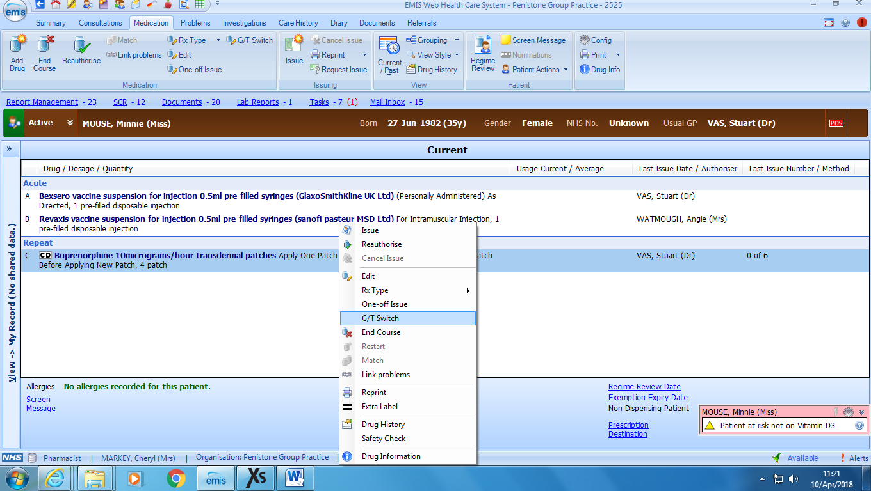
This will give you the various brand choices available. Click on the brand that you want to switch to and select OK (the dose and quantity will remain unchanged).
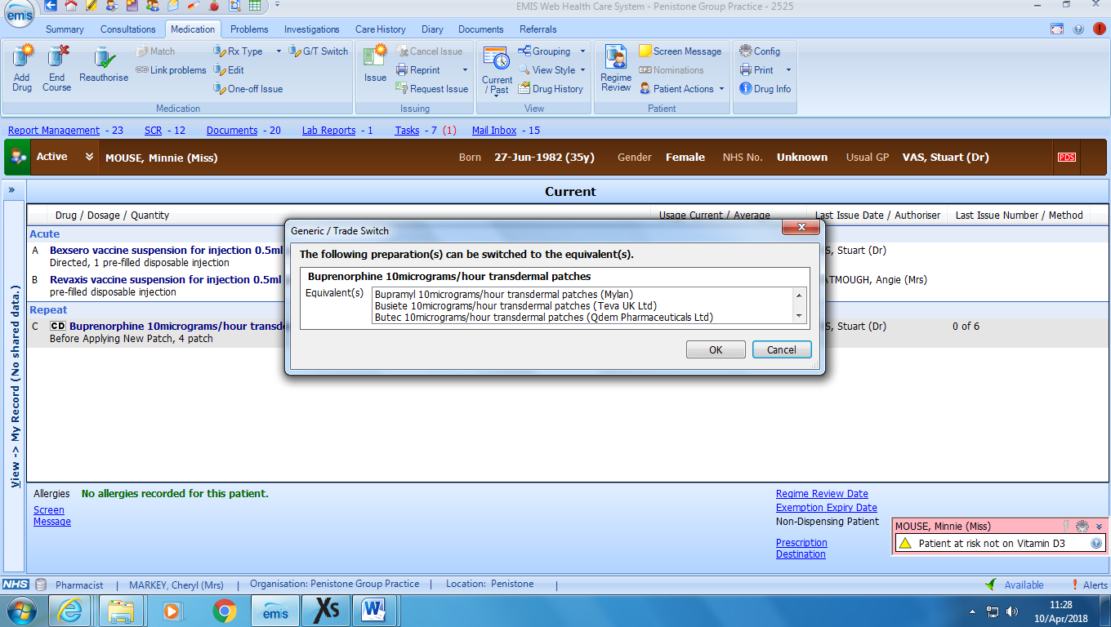Back to contents
The drug will have changed to the new brand. Add a script message with the drug name underneath to avoid potential confusion. Right click to edit the drug
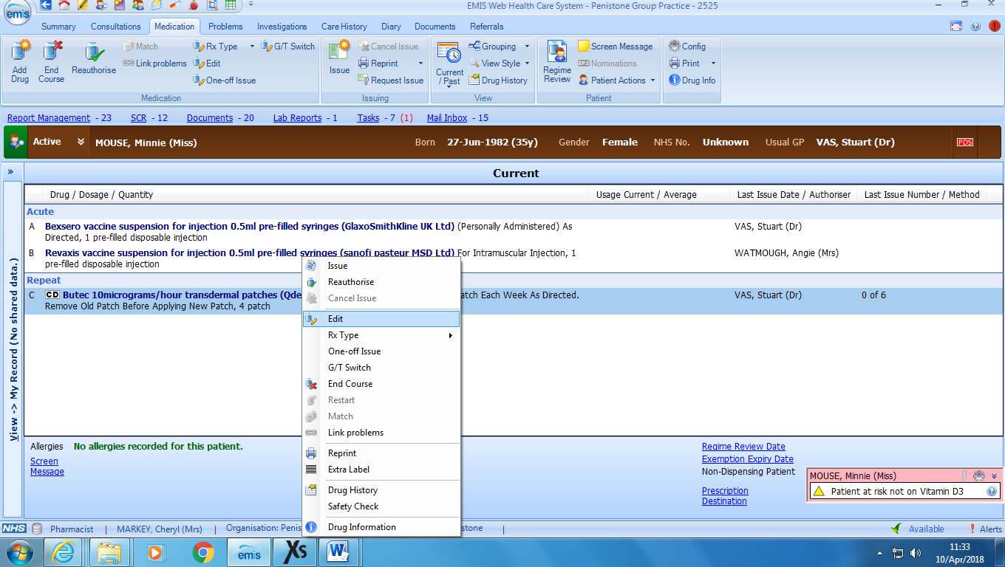

In the pharmacy info box add the drug name, (this text can be set up as a consultation synonym or copied onto a word document so that it can be pasted each time a patient is changed).

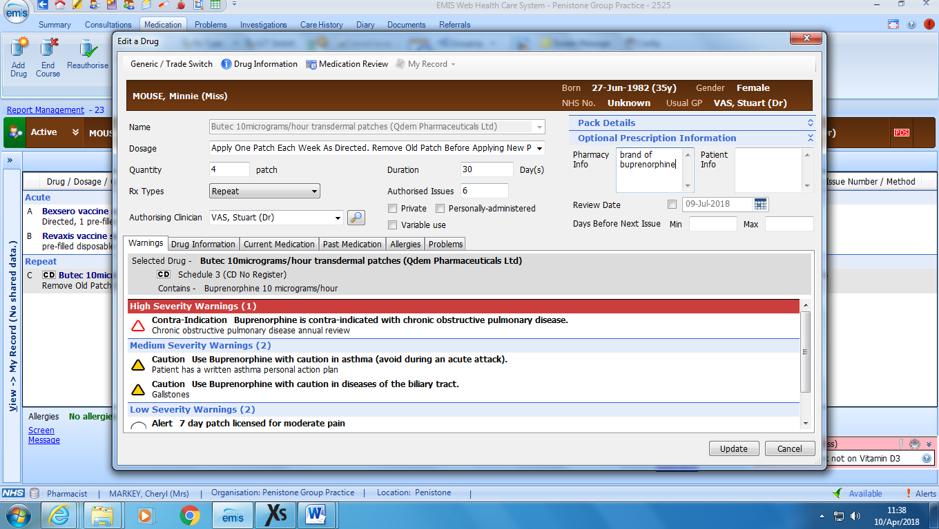
Back to contents
Add a consultation detailing the changes made – this provides an audit trail as to why the switch has been made and enables reception staff to reasure patients of changes made to medication if they contact the surgery.
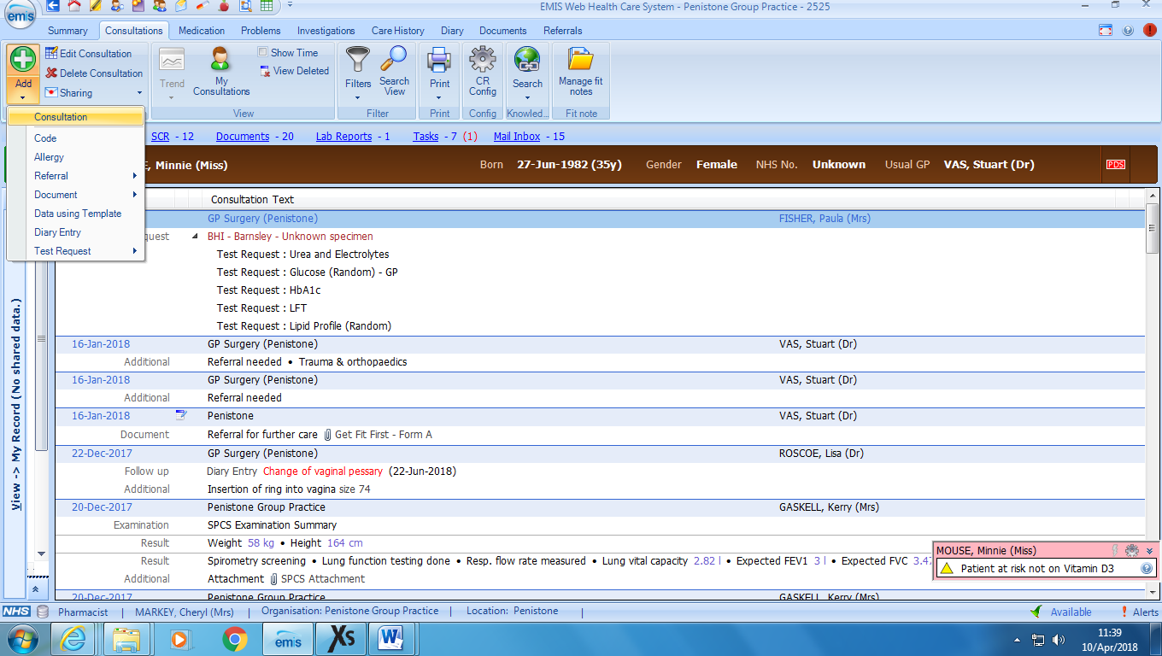
Pre-set consultation synonyms can be set up. This should detail the drug switched and the reason, who authorised it and when.
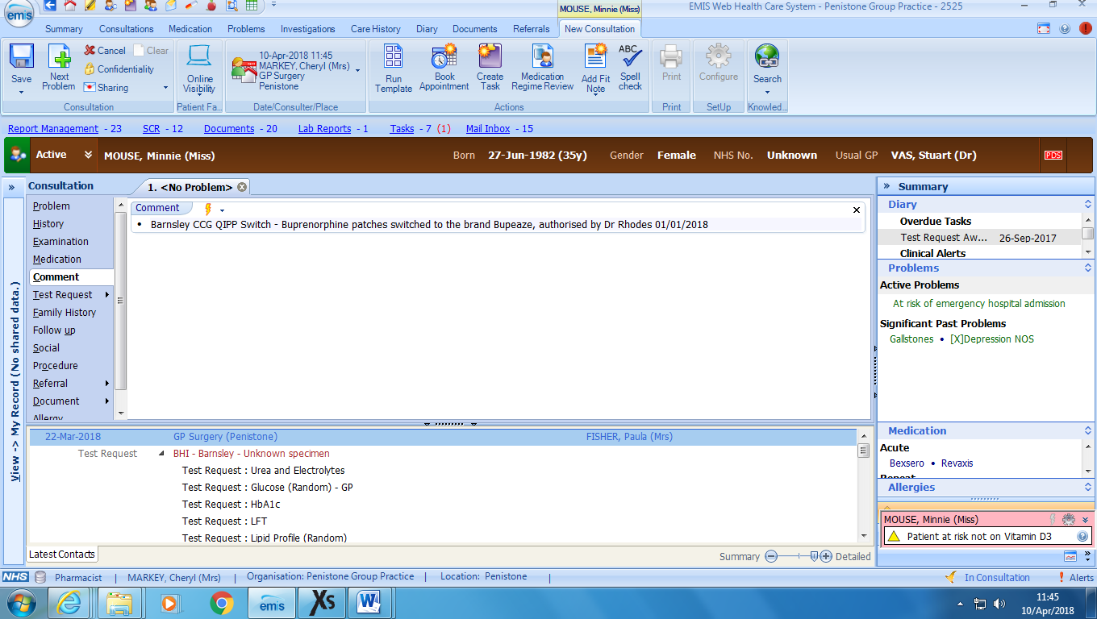

Back to contents
To set up the consultation synonym use the bottom section this will make the synonym visible to you and not the rest of the GP practice, (prescribers may use similar synonyms and may lead to errors).
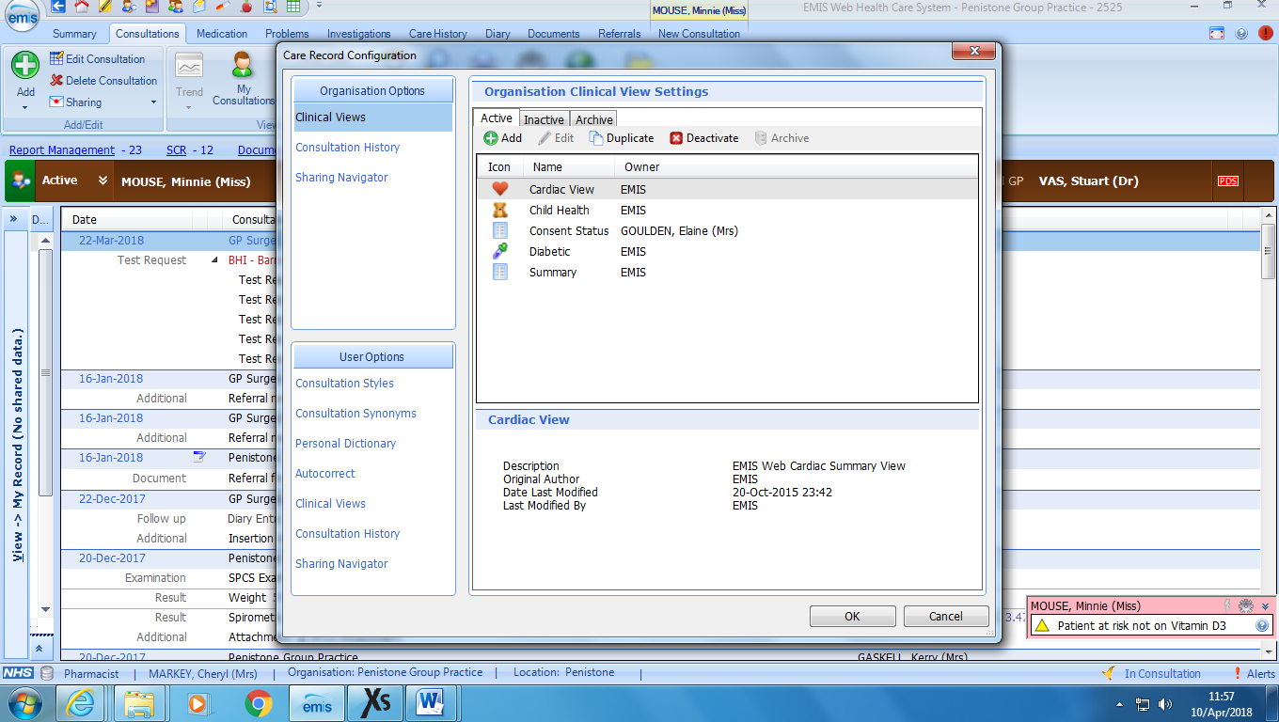
To attach a patient letter select the document option and then create letter
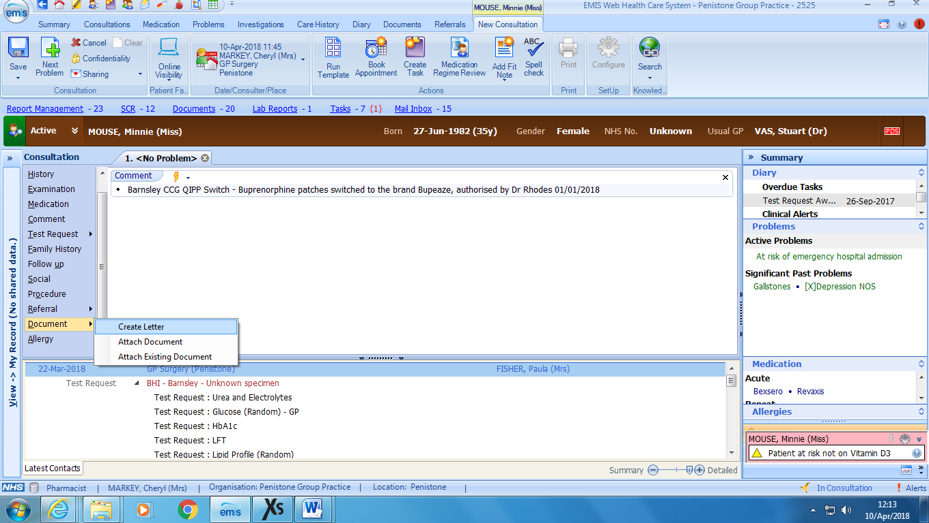

Back to contents
Use the magnifying glass to search for your pre-saved letter template
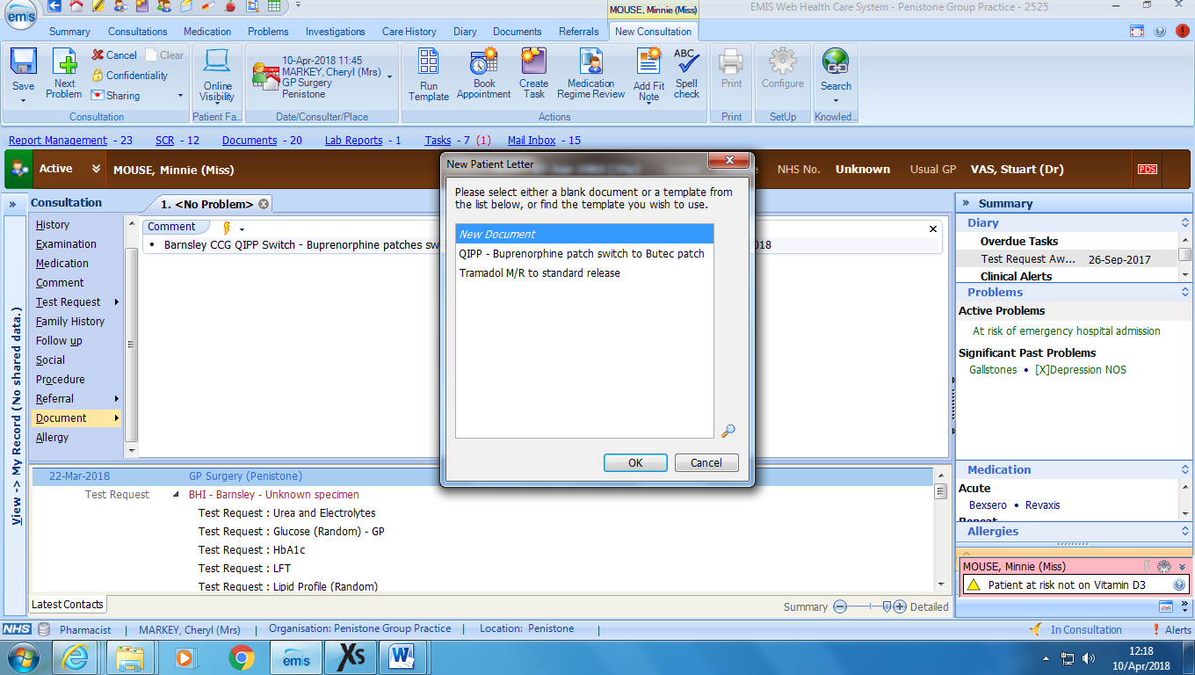

Once you have selected the required letter you can amend the content of the letter e.g. dose. Always double check patient details are displayed correctly.
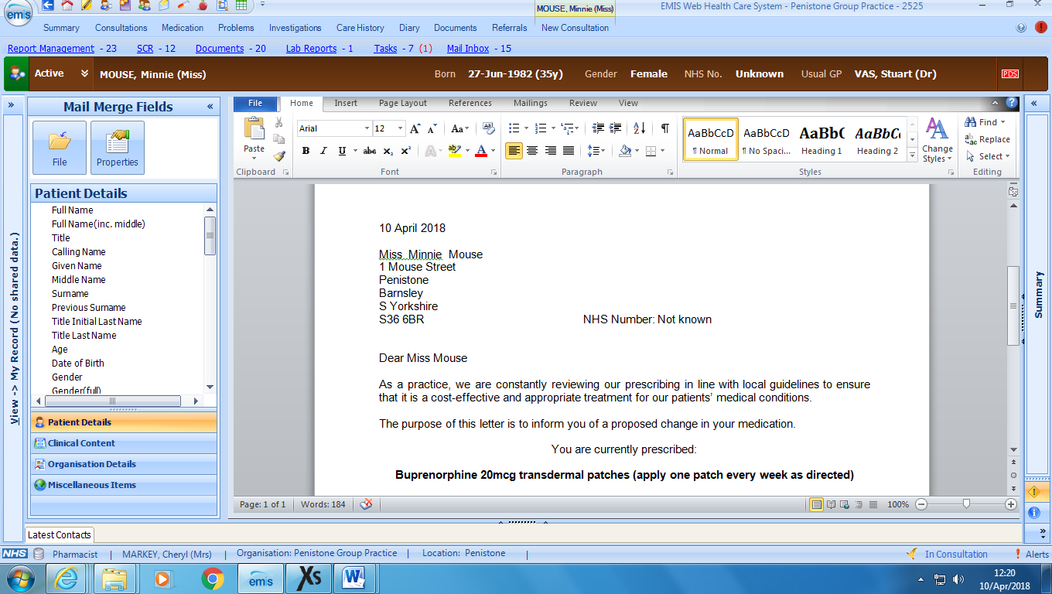

Back to contents
From the file icon print the letter and then save and close
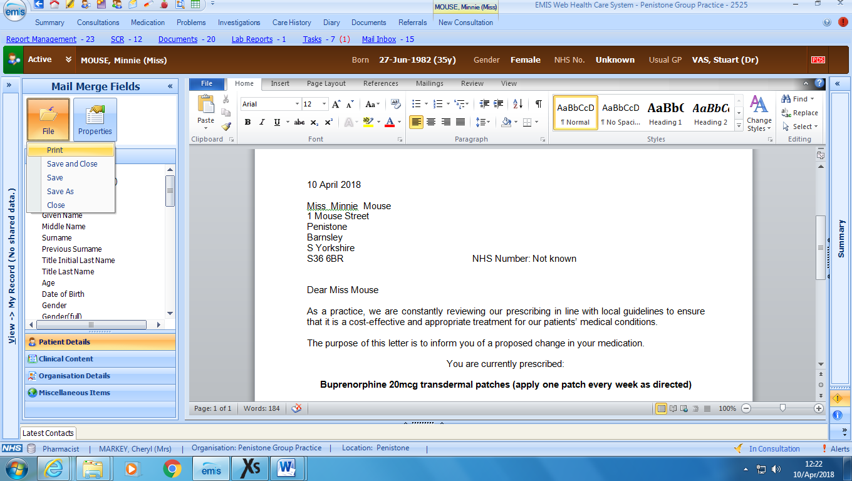
If the drug that you are adding is a new medication ADD it from the consultation section instead of using the G/T Switch function.
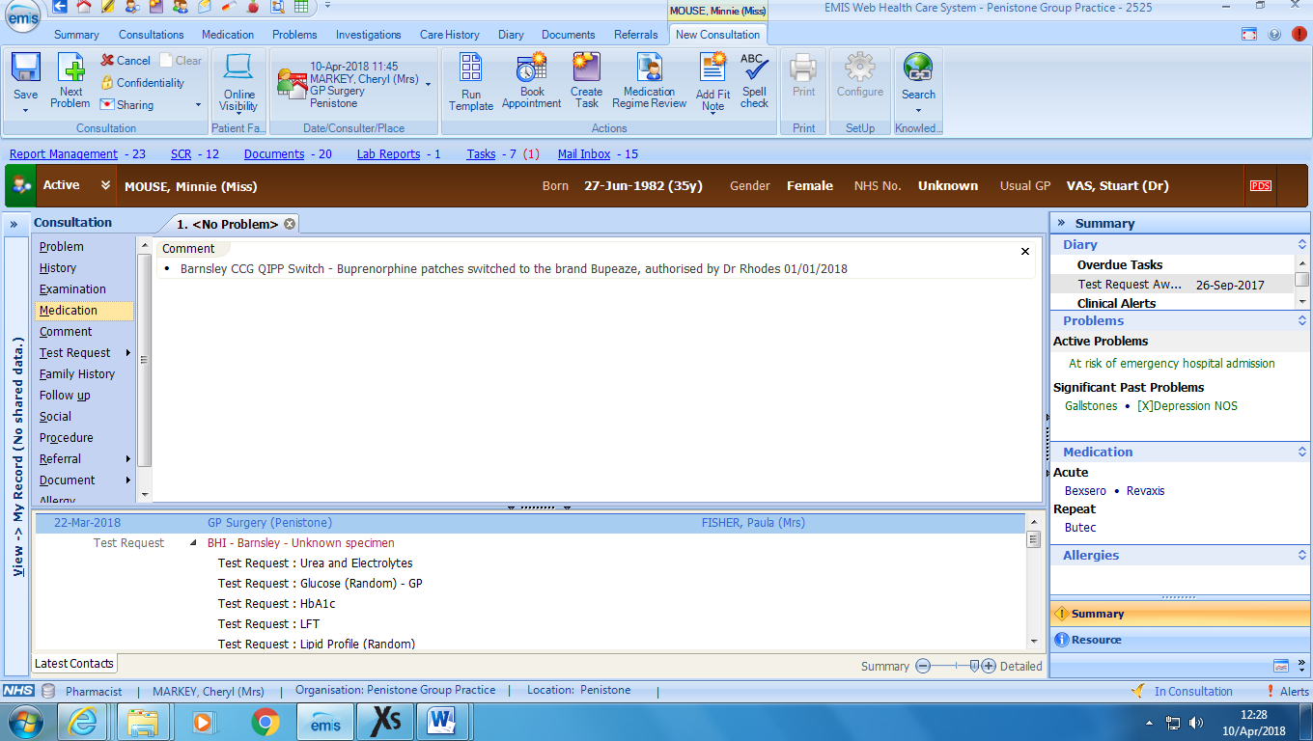
You can add the comment and attach the letter template all in the same way.

Back to contents
Once the new medication has been added, consultation added and letter created ensure that you then go back into the medication section to stop the old drug.
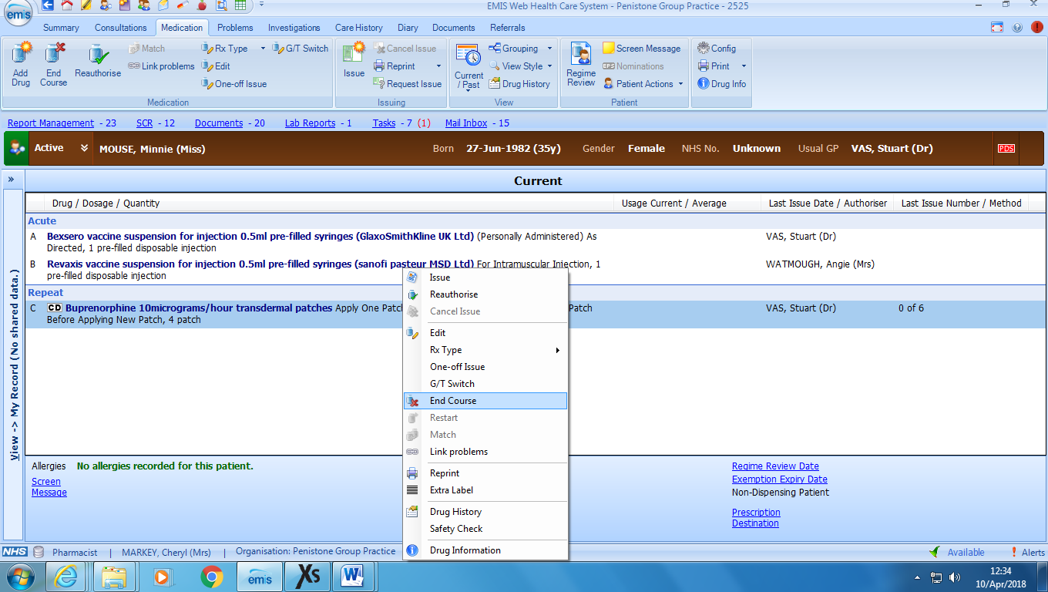
Always enter a reason for ending the course of the old drug e.g. ‘prescribed as the cost effective brand Sevodyne® ‘(this text can be copied onto a word document so that it can be pasted each time a patient is stopped).
Bulk Letters for Emis Web: letters can be done as a “Mail merge”. This saves adding a letter to patients’ records individually.
To do this:

  - Create Patient List by selecting Reporting/Population Reporting

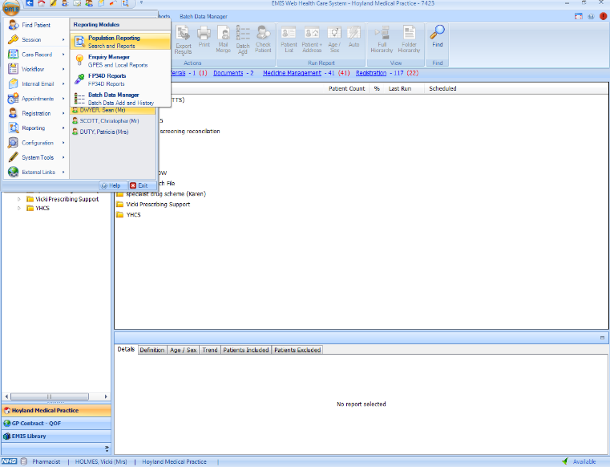

  - Select folder you wish to include the list in and select “Add/ List of Patients”
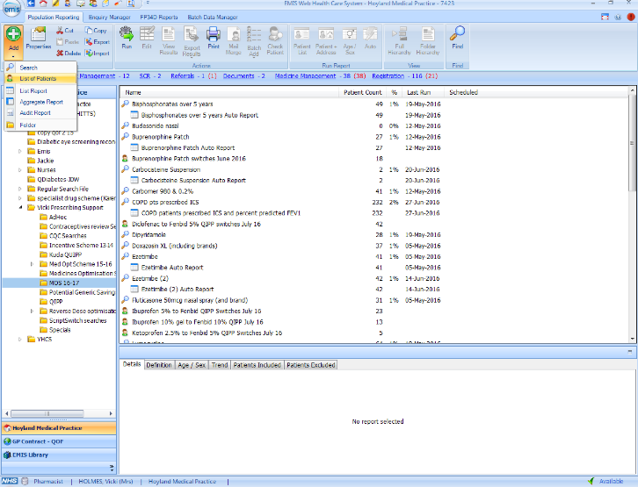

  - A list can be created using 3 options;
Option 1 - Manually create list by selecting “Add” and searching for patients using Emis number/patient name/NHS number
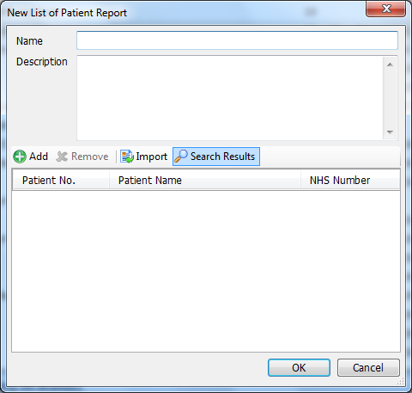
`
  - Option 2 - Import list of patients using NHS number – you will need to include in the patient auto list “NHS number” column and then copy this spreadsheet and remove all columns apart from NHS number before importing (needs to be saved as a CSV file not as an excel file)

Back to contents
Then select “Import” option and select file to import
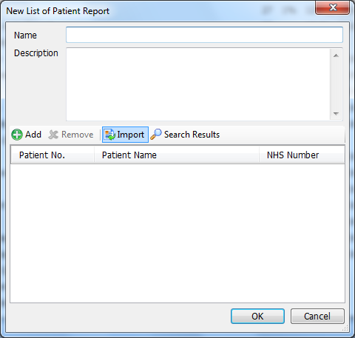

  - Option 3 - Import list using search results- this is only applicable if ALL patients on original search are being switched

Select required search using magnifying glass button, select search and press ok
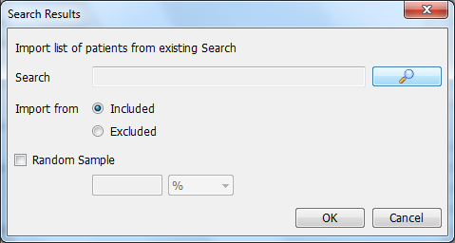
Back to contents
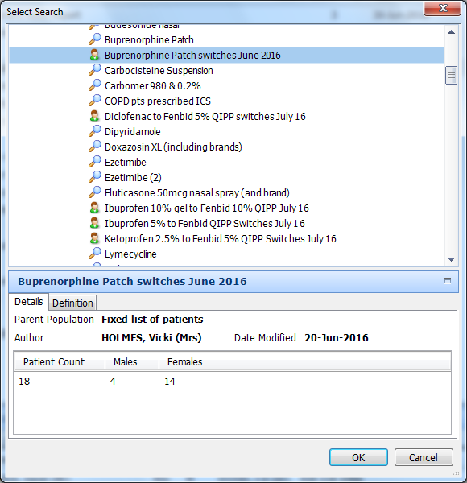

Once list is created and highlighted, select “Mail merge” icon at top of screen
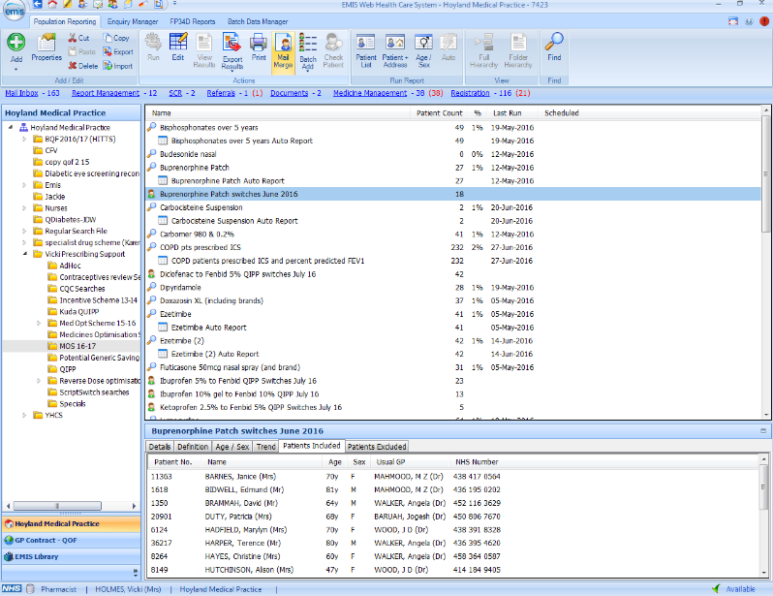

Select “ok” on pop up box
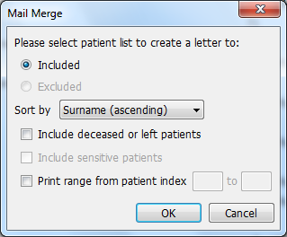

Back to contents
Select document template using magnifying glass
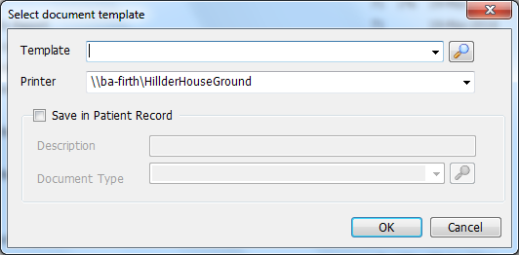

Select letter required from folder and click ok
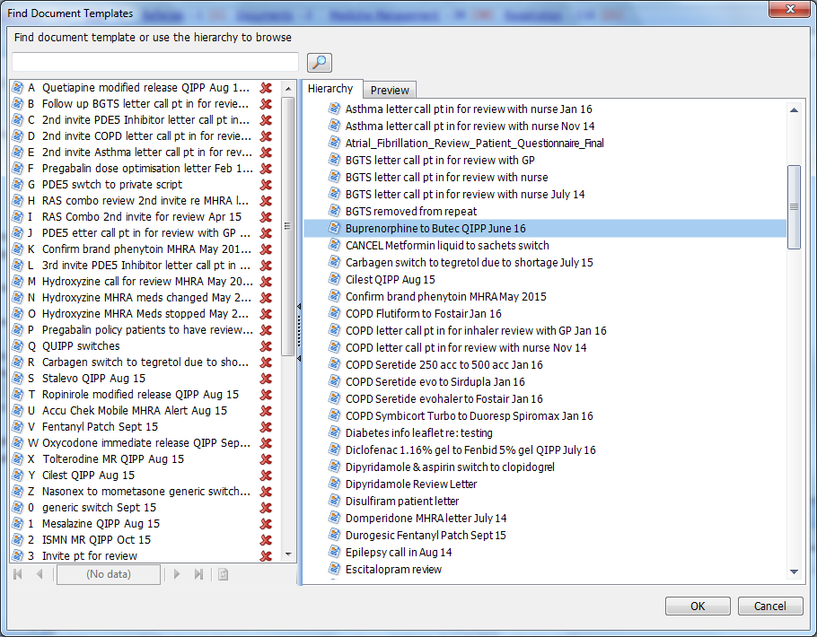

Select required printer & tick box “Save in Patients Record”. Type in description the medication you have changed from and which cost effective brand you have changed to and reason why i.e. QIPP
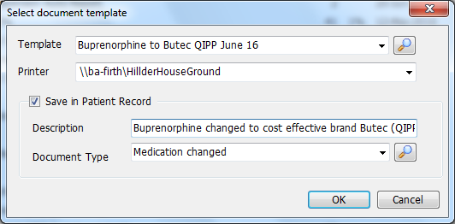

A letter will be printed for each patient. Please check addresses in case there are any discrepancies e.g. includes name of nursing home/house name as these are often missed.
Back to contents
Appendix D - SystmOne guide to changing medication

If medication is already linked to a problem – right click and select “New Repeat Based on This” (this keeps the problem linked to new drug)

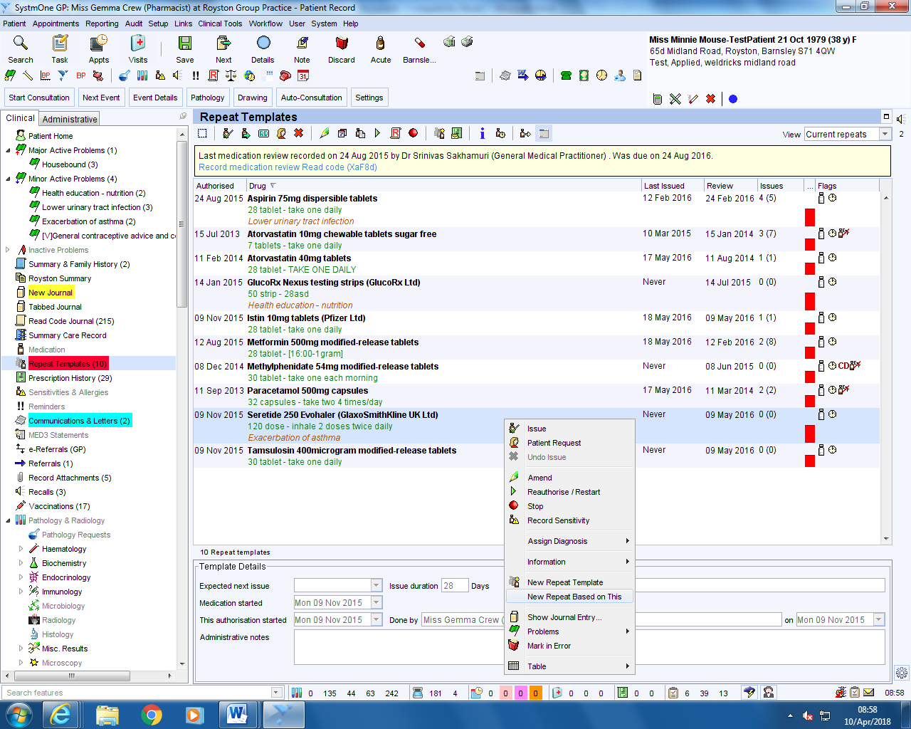

Click in the drug prescribed box and select the drug you are switching to
Add “Please note this is a brand of XXX drug in the script note box (a preset can also be created for this)

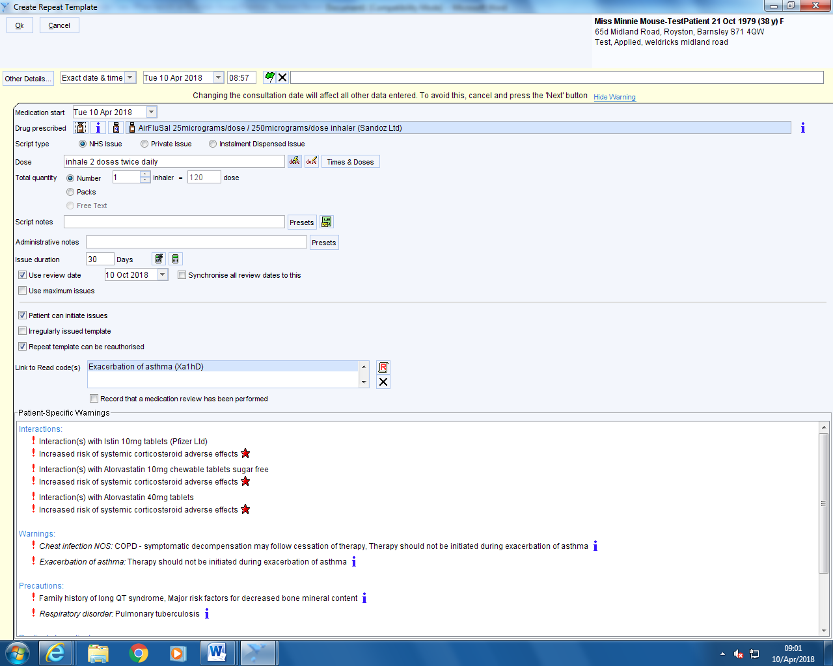

Back to contents
Once added new drug right click and stop the old one. For the comments select the appropriate preset.
To add new presets see next screen shot.

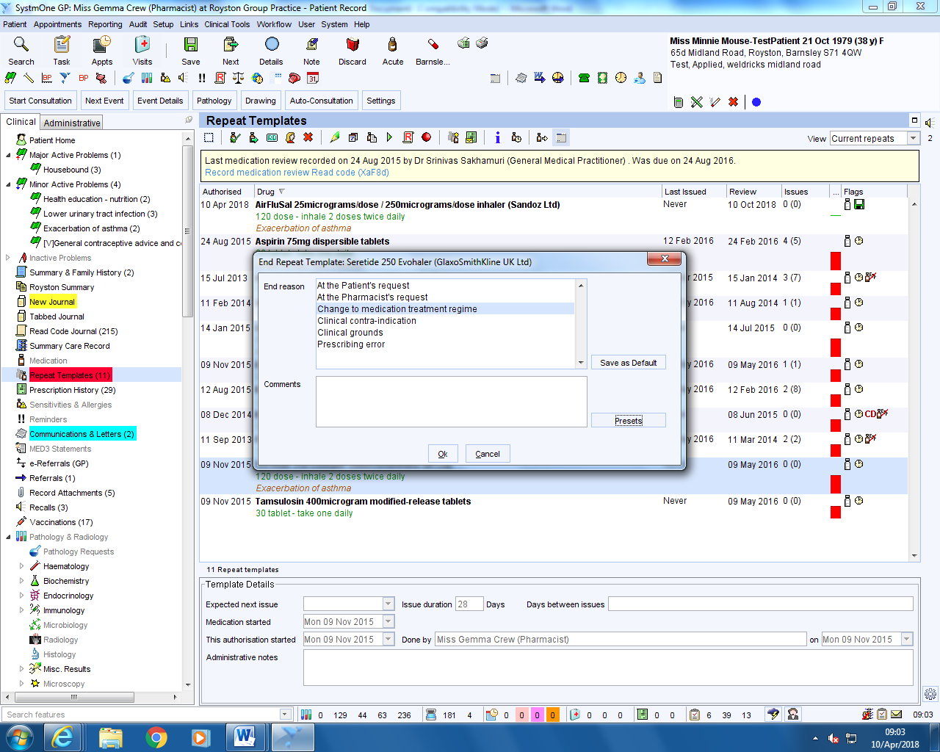

To add presets click the + button

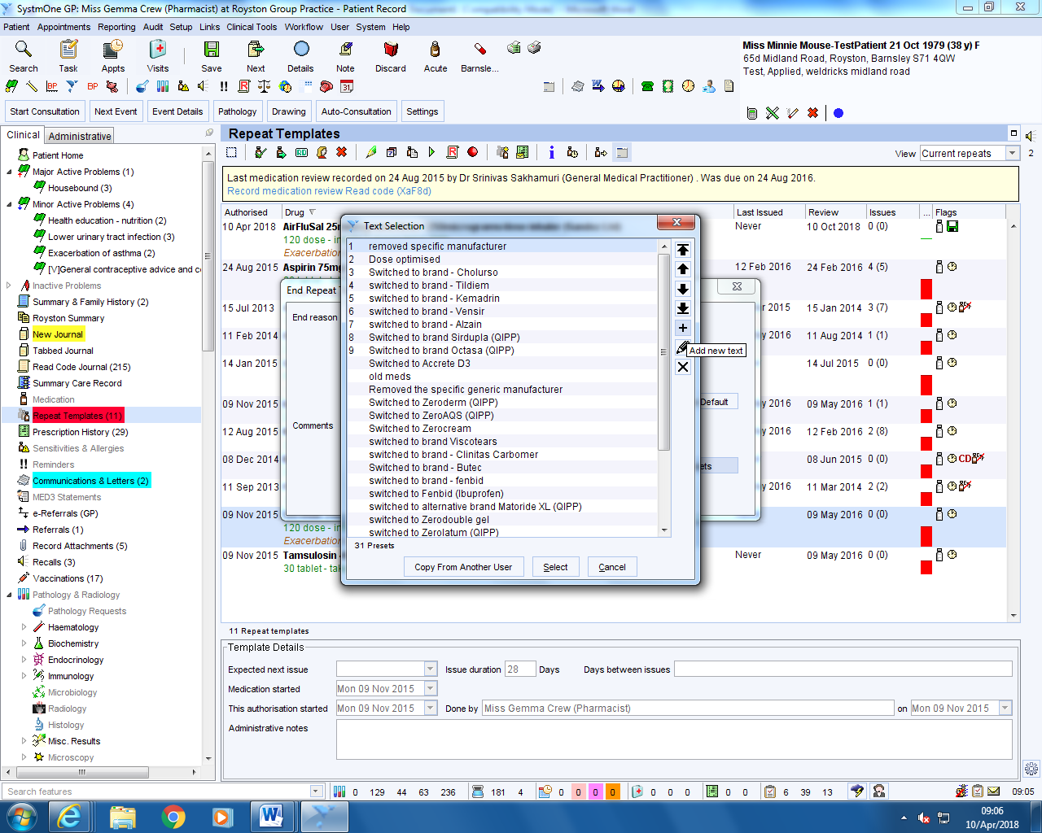

Back to contents
Once new drug added and old drug stopped, select note to add a quick note in patients New Journal.

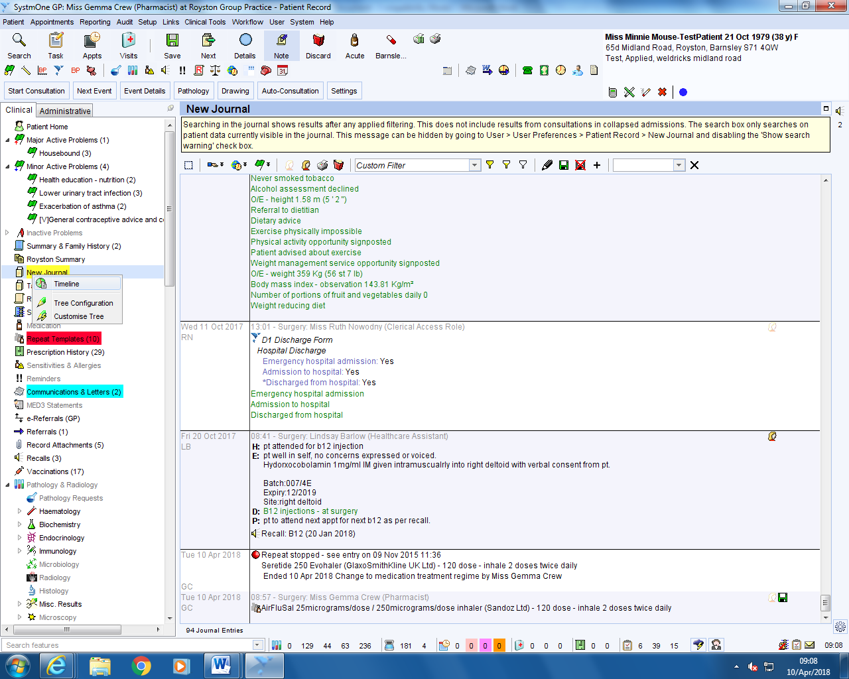

Select the preset (or add new one) that is relevant to the switch and click ok.

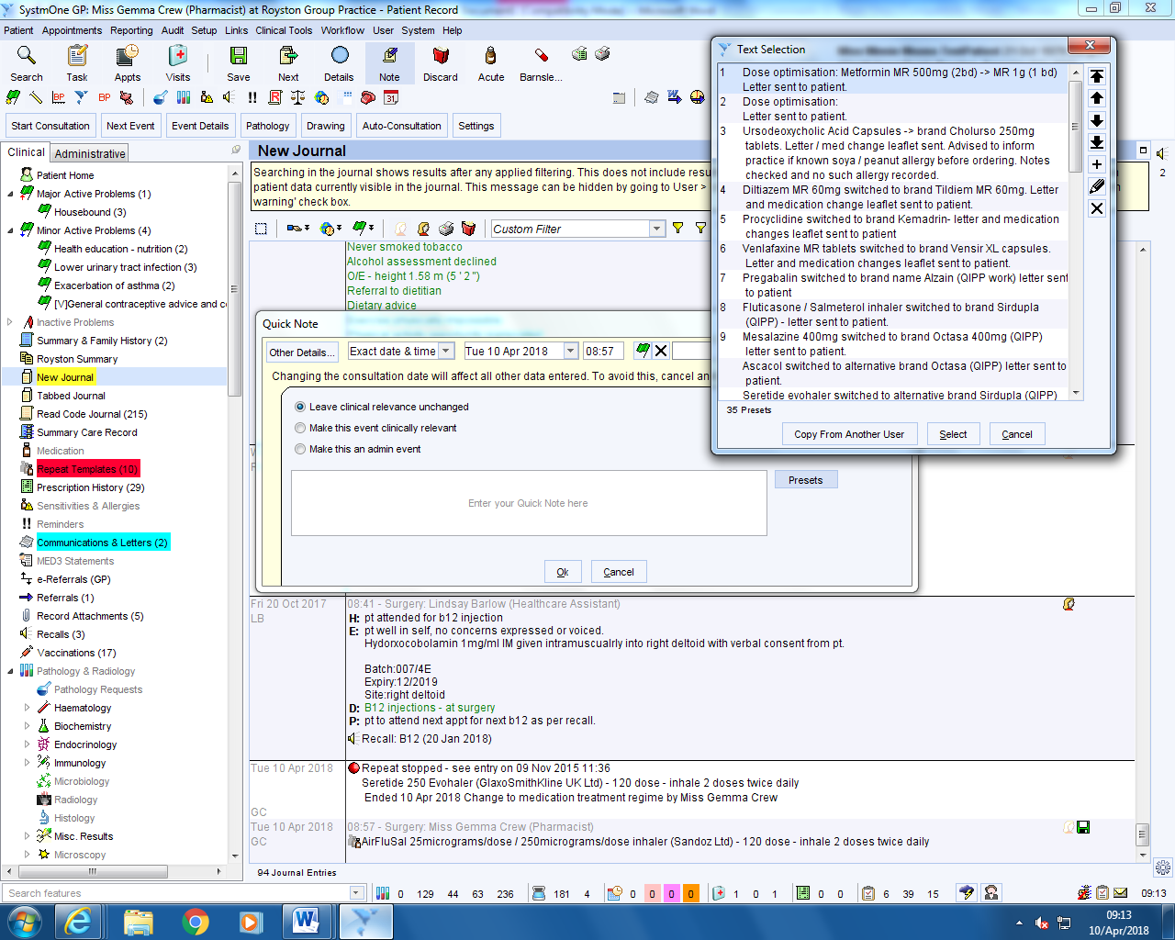

Back to contents
For the letter – right click on the communication and letters tab, select new letter. The sender and recipient type should be defaulted to “This organisation” and “The Patient”

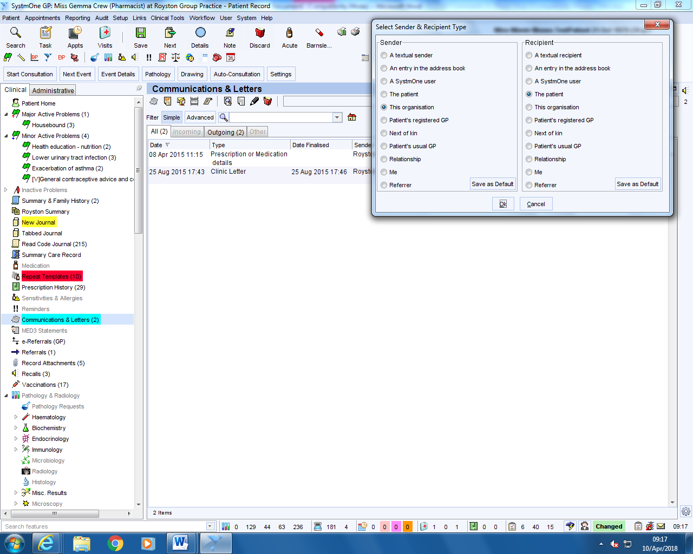

Ensure the Editor is MS word – select choose template, find the appropriate letter, double click and then select “Write Now

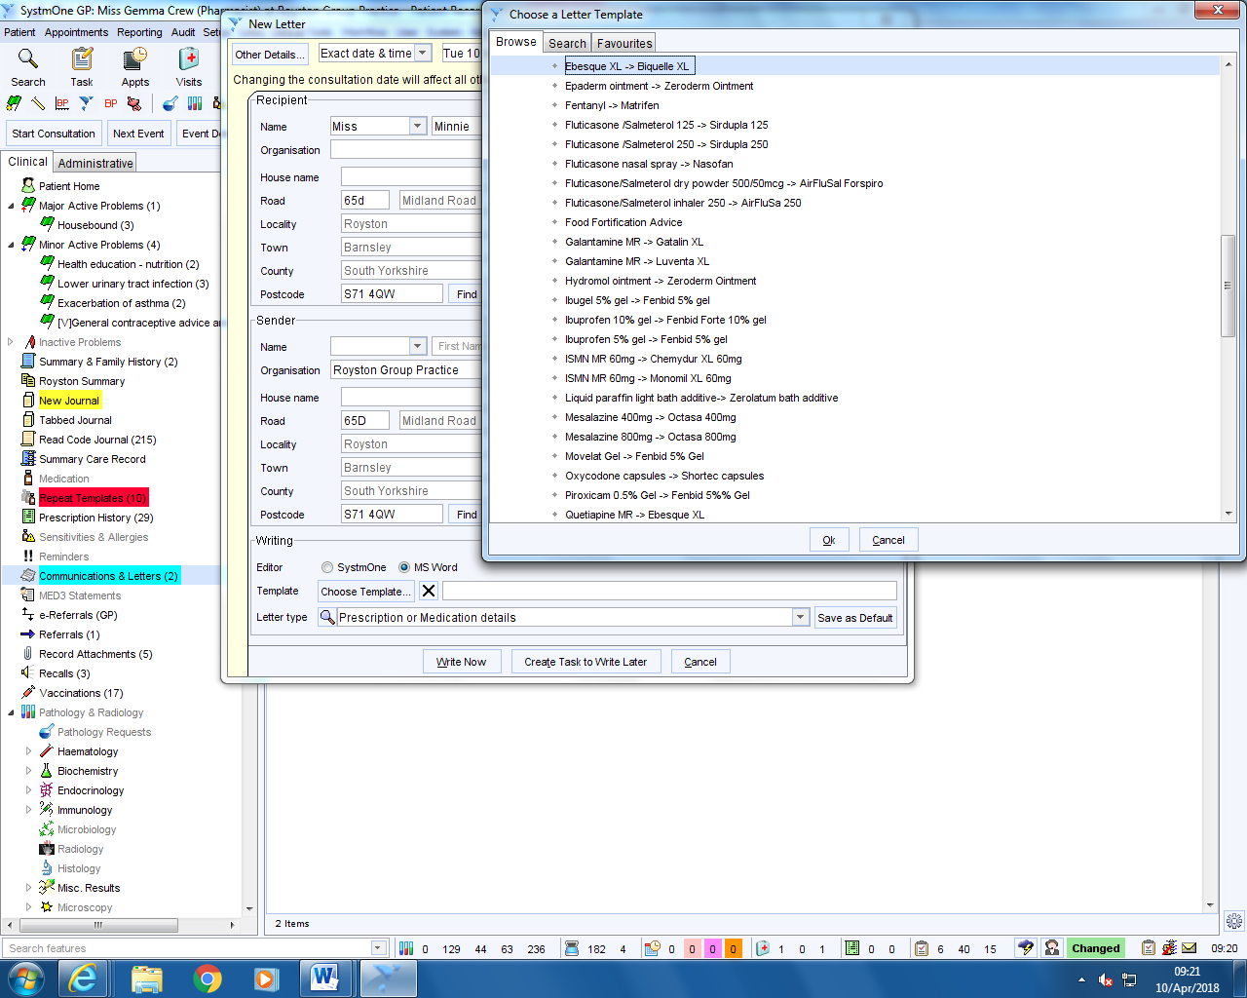

Back to contents
Once the letter is loaded and all correct, go to file, and print. Once printed select “Save Final Version”

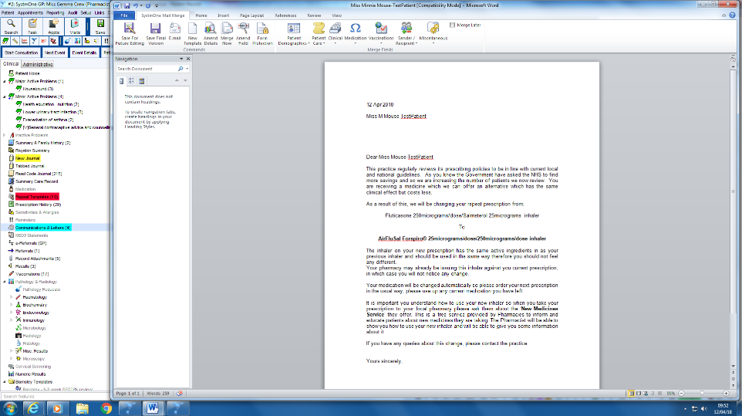

Once the letter is saved, the new journal displays all actions completed. Click “Save” before discarding the patient

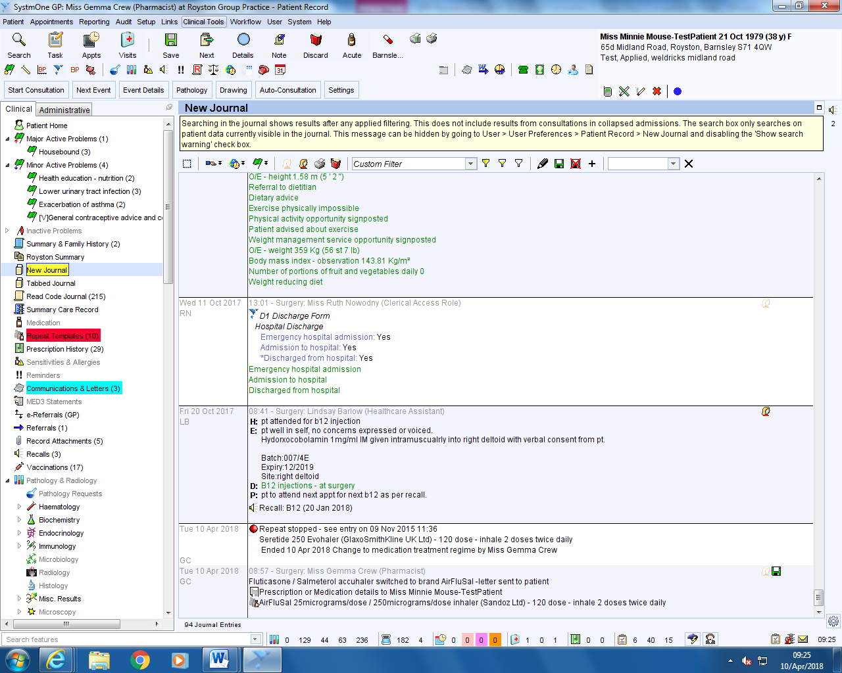

Back to contents
Bulk letters on SystmOne

To do this:
  - Create Patient List by selecting Reporting/Miscellaneous Reports/Ad-hoc patient list
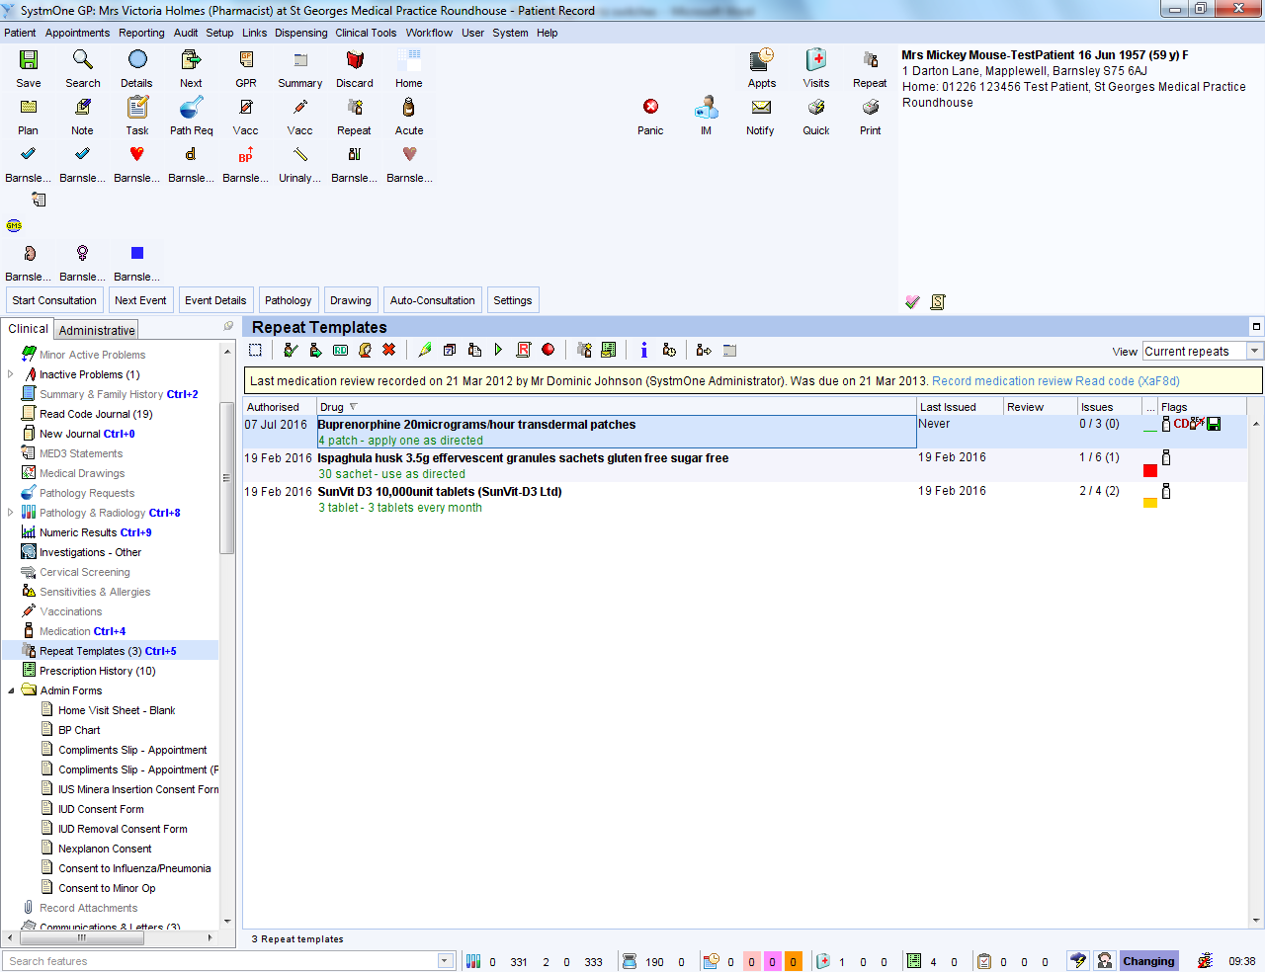
  - A list can be created using 2 options
    - Option1 - Manually create list by selecting “Add Patient” and searching for patients using patient name/NHS number
    - Option 2 - Import list of patients by selecting “Import CSV” – For patient confidentiality columns have been hidden on the screenshot below but do not need to be when importing



Back to contents
Once you have created the list/Imported list, select all patients by clicking on box icon on far left above list stating “Select all patients shown”
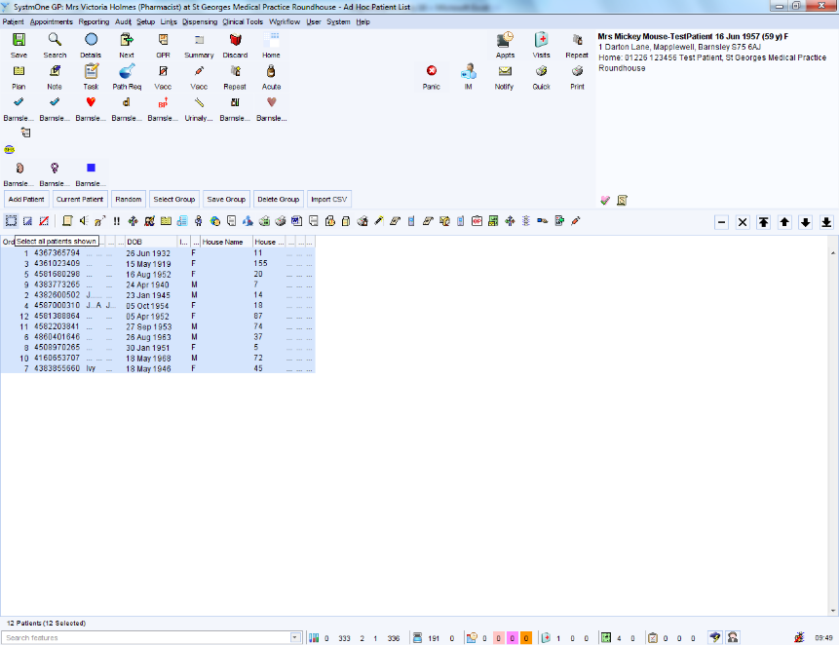

Right click on the list and select Actions/Print integrated word letters
Choose letter type as “Prescription/Medication details”
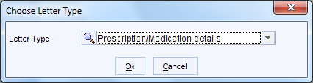

Select correct letter template
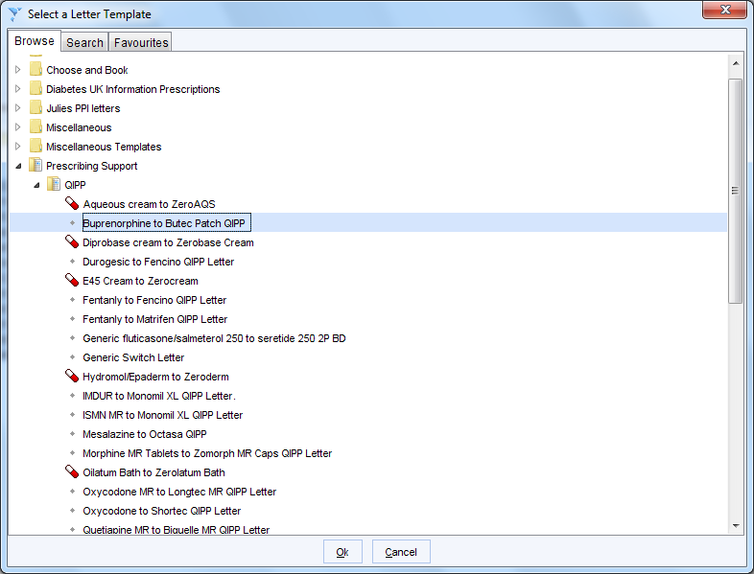

Back to contents
The documents will now be loaded. Select “Merge & Print”.

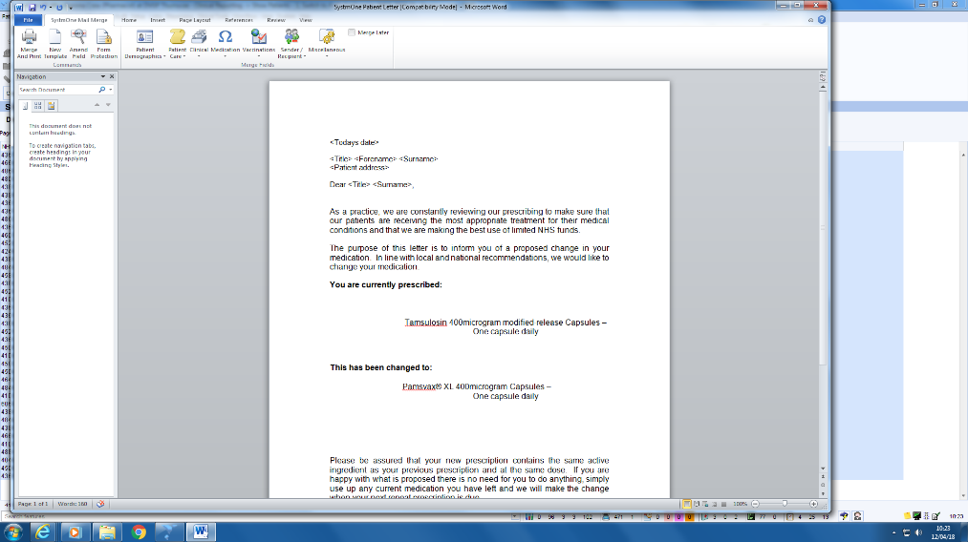

A letter will be printed for each patient. Please check addresses in case there are any discrepancies e.g. includes name of nursing home/house name as these are often missed.

Back to contents

