Change of inhaler brand from Clenil Modulite 200 to Soprobec 200
- Your Clenil Modulite 200 has been changed to the brand Soprobec 200.
- This inhaler works in the same way as Clenil and contains the same medication (beclomethasone) at the same strength.
- The new device is a have a dose counter however Soprobec does not come with a dose counter. If it is important to you to have a dose counter please speak to the practice.
- You should notice no difference in the management of your condition.
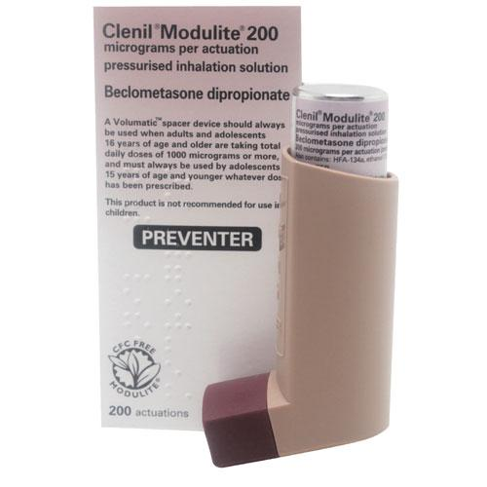
Your current inhaler looks like this:

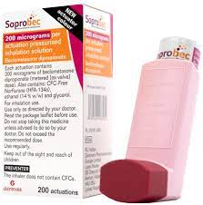
Your new inhaler will look like this:
- different colour it is light pink with a red/brown cap.

